Utilizing Isolation Forest and XGBoost Algorithms in Forecasting Unusual Trip Behavior as a Commuter Safety Indicator
CHAPTER 1
Background of the Study
Public transportation connects people to schools, workplaces, and other daily needs. Personal safety remains a concern, especially for commuters who travel alone or cannot easily call for help. These concerns can vary by time of day. A survey by UN Women (2021) in Kampala, Uganda, found that more than 80% of women felt unsafe on public transport late at night, compared with less than 8% during the daytime. The findings illustrate how perceptions of safety can change throughout the day.
In the Philippines, Corpuz et al. (2023) studied harassment on public transportation in Pampanga and found that young adults, particularly women aged 18 to 25, were most vulnerable and that reporting rates were low. When incidents go unreported, official records capture only part of what commuters experience. This motivates the development of tools that can flag trips that may need attention while they are underway, including in provincial areas such as Ilocos Norte.
Scarce incident records also make it difficult to train a system on examples of dangerous trips. Vehicle movement offers another source of information. A vehicle may stop for an unusually long time, move unusually slowly, or travel farther from its usual route. These patterns give a system a way to flag a trip for attention based on movement. Some safety concerns, including harassment inside a vehicle, may leave no observable trace in GPS data.
Current safety tools often depend on someone taking action. Agapito et al. (2025) described Pathfinders, a Philippine commuter safety application with GPS tracking and an emergency button. Its use depends on a commuter pressing the button or someone monitoring the trip on a live map. Some commercial ride-hailing services already check trips automatically. Uber’s RideCheck (Kansal, 2020), Lyft’s Smart Trip Check-In (Lyft, n.d.), and Grab’s Safety Call (Sasikumar, 2026) monitor for unusual activity such as long stops or route changes. These services illustrate how trip movement data can be used to flag potential safety concerns.
In academic research, Edwards and Hosein (2025) developed SayfTrip, which detects route deviations by checking how far a vehicle moves from its recorded path using fixed distance thresholds. A vehicle can behave unusually while staying on its usual route, such as when it makes a prolonged stop. The meaning of a stop also depends on context. A long stop may be routine at a busy terminal at noon but unusual on a quiet rural road late at night. Smartphone GPS errors add to this challenge. Trees, tall buildings, and bridges can interfere with satellite signals and make a vehicle appear to move away from its route (GPS.gov, n.d.). An overly sensitive detector may raise frequent false alarms, while a less sensitive detector may miss unusual events (Edwards & Hosein, 2025).
Other researchers have studied unusual stops in long-distance coaches using GPS records (Deng et al., 2024; Sabir et al., 2025), and Li et al. (2021) linked driving events such as long stops to road safety risks. These studies examine events after they occur and focus on coach operations or road crashes. In the literature reviewed for this study, a gap remains in using GPS data to learn an individual commuter’s usual travel patterns, assess departures from those patterns during a trip, and forecast the trip’s concern level over a short time window without relying on labeled incident records.
This study addresses that gap by developing and evaluating a machine learning pipeline that uses timestamps, latitude, and longitude from a smartphone’s GPS. The model is trained separately for each commuter using only that person’s own trip history. Each commuter’s usual travel patterns therefore serve as the reference for assessing their trips. The pipeline uses Isolation Forest (Liu et al., 2008) to score how unusual a trip’s movement is. It combines that score with GPS-derived movement features, including distance from the usual route and stop duration, to assign a current concern level. XGBoost (Chen & Guestrin, 2016) forecasts that level a short time ahead. A prototype application records trips and displays the model’s output as a proof of concept. The evaluation focuses on the machine learning pipeline and excludes app usability, battery use, and alert delivery.
The study evaluates the model on recorded trips along local transit routes in Ilocos Norte. For each test trip, training uses only trips that the person taking that trip recorded earlier. As more of that person’s trips become available for training, the study compares forecast accuracy with a simple baseline, checks whether predicted probabilities match observed outcomes, and measures how often the model flags documented unusual events and raises false alarms. The concern level indicates whether a trip’s movement may warrant attention. The study uses this evaluation to establish a baseline for future commuter safety tools built from smartphone GPS data.
Statement of the Problem
Safety concerns on public transport often go unreported, so commuters who travel alone or cannot call for help have few tools that notice, while a trip is under way, that it may need attention. This study therefore asks three questions.
- How can GPS data from trips along local transit routes in Ilocos Norte be used to measure speed, stops, and distance from the route?
- How can Isolation Forest and XGBoost be combined to score unusual trip movement, assign a concern level from normal to critical, and forecast that level over a short time window?
- How well does the model perform as more trips are added to the training data?

Objectives of the Study
The general objective of this study is to develop and evaluate a machine learning model that uses Isolation Forest and XGBoost to identify unusual trip movement and forecast a commuter’s trip concern level from GPS data, as an indicator that a commuter's trip may need attention.
Specifically, this study seeks to:
- collect and clean GPS data from trips along local transit routes in Ilocos Norte and derive measures of speed, stops, and distance from the route;
- develop a model that uses Isolation Forest to score how unusual a trip’s movement is, combines that score with the vehicle’s distance from its usual route and the duration of its stops to assign a current concern level from normal to critical, and uses XGBoost to forecast that level a short time ahead; and
- Evaluate model performance as each commuter’s travel history grows by training only on their earlier trips and testing on later ones, assessing forecast accuracy against a simple baseline, probability calibration, detection of documented unusual movement, and the false alarm rate on confirmed ordinary trips.

Significance of the Study
This study examines whether basic smartphone GPS data and machine learning can detect and forecast unusual trip movement without relying on incident reports or manual calls for help. By evaluating the model on recorded public transit trips, the study provides evidence on forecast accuracy and how often routine travel patterns trigger false alarms. The findings may benefit the following groups.
Researchers and the academic community. The study provides a method and baseline results for detecting and forecasting unusual movement on everyday public transit routes. Researchers and students can build on its GPS-derived movement features and evaluation approach, including the use of each commuter’s own trip history to establish their usual travel patterns.
Software developers and engineers. The study provides a technical starting point for future commuter safety applications. It describes how to clean smartphone GPS records, derive movement features such as speed, stop duration, and distance from the usual route, and use Isolation Forest and XGBoost to assess current trip movement and forecast a concern level. The evaluation results can help developers judge whether the approach is suitable for automated check-in features.
Future commuters. Future safety tools could use this approach to flag unusual movement while a trip is underway, including when a commuter cannot easily call for help. By measuring how often the model raises false alarms on ordinary trips, the study helps establish whether the approach is dependable enough for future tools.
Families and guardians. Future tools could use the model’s output to prompt a check-in when a trip’s movement differs from the commuter’s usual patterns. This could give families and trusted contacts a reason to check on someone without having to monitor a live map throughout the trip.

Scope and Delimitations of the Study

Definition of Terms

CHAPTER 2
REVIEW OF RELATED LITERATURE
2.1 Introduction
This chapter reviews related studies and tools. It first looks at commuter safety in the Philippines and at the tools that already exist. It then follows the three objectives of this study: gathering and preparing GPS data, building the model, and evaluating the model. It ends with a summary of the gap in the literature and the conceptual framework.
2.2 Commuter Safety in the Philippine Context
Safety worries change with the time of day. A survey by UN Women (2021) asked 2,548 women in Kampala, Uganda about public transport. More than 80% felt unsafe late at night, compared with less than 8% in the daytime. This is another country, but it shows why the time of travel matters.
In the Philippines, Corpuz et al. (2023) studied harassment on public transport in Pampanga. Young adults, especially women aged 18 to 25, were the most affected, and reporting rates were low. Many incidents are never reported, so a safety tool cannot depend on past reports.
Commuters use different public vehicles. In Metro Manila, Okamura et al. (2013) studied what jeepney riders look for beyond fare and travel time, and security was one of the things they asked about. In Ilocos Norte, Baluan et al. (2026) studied jeepney and tricycle drivers in Sarrat, so both vehicles serve the province. These studies describe the setting, but they do not look at monitoring trips for safety.
Most safety tools need a person to act. Agapito et al. (2025) described Pathfinders, an app for Metro Manila with GPS tracking and an emergency button. The commuter must press the button, or a parent must watch the map. Some ride-hailing services check trips on their own. Uber's RideCheck notices an unexpected long stop and asks if help is needed (Kansal, 2020). Lyft checks rides for unusual activity such as long stops (Lyft, n.d.). Grab's Safety Call phones passengers after a sudden route change, a long stop, or a trip that is not moving forward (Sasikumar, 2026). These features inspired this study: watch the trip, and check on the commuter when something looks unusual.
2.3 Gathering GPS Trip Data
A GPS trip record is a list of positions, each saved with its time. Each record has three parts: the time, the latitude, and the longitude. Edwards and Hosein (2025) saved these same three parts on a phone for each trip on a route. This study does the same with a prototype recording app.
How often a position is saved decides what the data can show. A short event can be missed if it falls between two records. Newson and Krumm (2009) found that their map matching got worse as the GPS rate got lower. Studies of long-distance intercity buses have the same problem. Their GPS often saves a position only every 30 seconds to two minutes, which can hide short stops (Deng et al., 2024; Sabir et al., 2025). Deng et al. (2024) say a 30-second gap is too long to tell whether a bus has stopped.
This study saves one position every 10 seconds. This is at least three times finer than the bus GPS in those studies, and it is fine enough to see the stops this study cares about. Sabir et al. (2025) give pauses under 40 seconds as an example of brief stops. With a record every 10 seconds, a 40-second stop has about four records, enough to show that the vehicle stayed still. A 30-second gap could give only one record or none. Edwards and Hosein (2025) note that phones can check location as often as once per second, although this uses more battery. A 10-second interval uses less battery while still being much finer than bus GPS. Other smartphone studies also used 10 seconds. Bagheri et al. (2020) sampled every 10 seconds while travellers were moving, to describe the trip route accurately enough, and Mears et al. (2021) requested a location every 10 seconds and note that this is a common recording interval for GPS data.
GPS is never exact. GPS.gov (n.d.) explains that buildings, bridges, and trees make positions less accurate. A position can be off, and a trip can look like it left the route when it did not. The records therefore have to be cleaned.
Recording trips also involves personal data. Under the Data Privacy Act of 2012 (Republic Act No. 10173), consent must be freely given, specific, and informed, and Section 12 lists when personal information may be processed. People who record or ride on the trips must give informed consent, and the records must be handled with care.
2.4 Cleaning and Preparing GPS Records
2.4.1 Cleaning GPS Errors
Raw GPS records need cleaning first. Zheng (2015) puts preprocessing early in the process. Common steps are removing noise, finding stay points (places where a vehicle stayed for a while), and map matching. Noise often comes from weak signals, such as in areas with tall buildings.
The first cleaning step removes GPS errors. A common way is to check the speed between two records. If a record implies a speed that a vehicle cannot reach, the record is an error. Chen et al. (2016) call speed thresholding probably the most popular method, but they note that the limit is hard to choose without knowing how the object moves, and that it can miss small errors. Verma et al. (2024) cleaned smartphone GPS data by removing records with a segment speed above 50 m/s (180 km/h) and records with an acceleration outside the range of -10 to 10 m/s². They also removed records with a reported error radius above 50 m. This study uses the same speed and acceleration limits. A speed of 50 m/s is 180 km/h, far above the highest limit in the Land Transportation and Traffic Code, which is 80 km/h for passenger cars and motorcycles on open country roads (Land Transportation and Traffic Code, 1964, Sec. 35). If a record implies a move faster than 50 m/s from the last accepted record, or an acceleration outside the range, it is treated as a GPS error and removed. The next record is then checked against the same last accepted record. This study records only time, latitude, and longitude, so it cannot use the error radius rule. Records that are duplicated, out of time order, or missing values are also removed. Small errors can still pass these checks, so later steps compare the measures with earlier trips as well.
2.4.2 Measuring Stops, Route Distance, and Speed
Stops matter a lot in this study. Deng et al. (2024) estimated stops from sparse coach GPS and separated unusual stops from normal ones. Sabir et al. (2025) compared how long a stop lasted with the usual stay in that part of the route. Both compare a stop with what is normal for the place. Sabir et al. (2025) also set a low-speed limit of 5 km/h to decide that a vehicle has stopped, and this study uses the same limit.
Distance from the usual route is also measured. Edwards and Hosein (2025) used the shortest distance between the current position and the positions of earlier trips on the same route. Newson and Krumm (2009) used map matching to find the most likely road behind noisy positions.
Speed, acceleration, and stopping time come from the positions and times. Li et al. (2021) did this for buses. They defined hard acceleration, hard braking, and long stops from acceleration and stop time. Edwards and Hosein (2025) link every point to its trip, so a new position can be compared with earlier trips on the same route.
2.5 Modelling Unusual Trip Behavior
2.5.1 Signals of Unusual Movement
Two signals are common in studies of unusual trips: leaving the expected route, and stopping where a stop is not expected. Edwards and Hosein (2025) put the distance from earlier routes into four levels: normal up to 150 m, minor up to 500 m, major up to 1,000 m, and critical beyond 1,000 m. They set these limits in advance. Ride-hailing features look for long stops and route changes (Kansal, 2020; Lyft, n.d.; Sasikumar, 2026). In a bus fleet, long stops, hard acceleration, and hard braking were each linked to crashes involving pedestrians and cyclists near bus stops, and long stops had the strongest link (Li et al., 2021). Deng et al. (2024) looked for unusual coach stops, such as stops at places where passengers should not be picked up. Their concern was coach safety, not harassment, so it supports finding unusual stops from GPS but not what a stop means for a commuter. In these studies, unusual movement is treated as a possible warning sign, not as proof that something is wrong.
SayfTrip (Edwards & Hosein, 2025) saves each trip on the phone and compares each new position with earlier trips on that route. In the proof of concept, its detector looks only at location, not at timing. A vehicle can stop for an unusually long time near a familiar road without crossing a distance limit, and the fixed limits treat every part of the road the same.
2.5.2 Unsupervised Detection and the Isolation Forest
Labelled dangerous trips are rare, so methods that learn what is normal without labels are a good fit. The Isolation Forest (Liu et al., 2008) finds unusual points by how easily they can be separated from the rest, and it is fast and light. Liu et al. found that 100 trees built on samples of 256 points were enough, and this study uses the same settings. Zhang et al. (2011) used this idea on taxi GPS traces in iBAT. It found more than 90% of unusual trips with a false alarm rate under 2%. Chen et al. (2013) extended it in iBOAT, which compares a trip with normal routes for the same time period and points out which part is unusual. In one month of data from 7,600 taxis, they found about 43,800 unusual trips and concluded that most were likely deliberate fraud by drivers. So what is flagged depends on the setting, and a flagged trip is not a sign of danger by itself. Hariri et al. (2021) showed that standard isolation forests can give uneven scores and proposed the Extended Isolation Forest to fix this.
What is normal depends on the place and the time. iBOAT compares a trip with history for the same time period, and Sabir et al. (2025) compare a stop with the usual stay in the same part of the route. Fixed rules do not do this. A stop at a busy terminal at noon is normal, but the same stop on a quiet road at midnight is not. These studies support scoring each moment against the history of the same place and time. SayfTrip builds its history from the user's own earlier runs of a saved route (Edwards & Hosein, 2025), and this study does the same, so each commuter has an independent history. That history should stay recent, because old trips may no longer show what is normal (see Section 2.6.3).
2.5.3 Ordered Concern Levels
A safety tool should say how serious a situation is, not only whether it is unusual. Edwards and Hosein (2025) do this with four distance levels. Frank and Hall (2001) show a simple way to predict ordered levels with ordinary classification methods. The problem is turned into yes-or-no questions, such as "is the level above Minor?", and the answers are combined. This allows ordered levels such as Normal, Minor, Major, and Critical. For the Isolation Forest score and the length of a stop, the levels need a rule for how far from normal is far enough. A robust score does this by measuring the distance from the median in units of the median absolute deviation, so a few extreme trips do not distort it. Leys et al. (2013) recommend 2.5 as a cut-off, and Iglewicz and Hoaglin recommend labelling scores above 3.5 as potential outliers (as cited in NIST/SEMATECH, n.d.). This study uses 2.5 for Minor and 3.5 for Critical, and puts Major halfway at 3.
2.5.4 Making Labeled Data from Unlabeled Trips
XGBoost is a supervised method, so unlabeled trips have to be turned into labeled data first. It learns from examples that come with answers, called labels. The trips in this study have no labels, because nobody marks which moments were unusual. Other studies made labels from the data when labels were scarce. Bakker et al. (2025) trained models on labels made from Isolation Forest and autoencoder scores, and Yuan et al. (2024) gave pseudo-labels to unlabeled samples.
In this study, the labels are made in three steps from what the earlier sections described. First, each moment of a cleaned trip gets its measures (Section 2.4.2) and a concern level from Normal to Critical, which combines the Isolation Forest score, the distance from the route, and the stopping time (Sections 2.5.2 and 2.5.3). Second, each moment gets its label, which is the worst concern level in the forecast window, the short time ahead that the Model looks at. This uses the records that come after the moment. Third, the measures at the moment come only from the present and the past. They are the inputs, and the label is the answer. The window starts at one minute, because a forecast has to arrive in time for a check-in. In SayfTrip, when a route deviation reaches the critical level, the user has 30 seconds to answer before a message goes to an emergency contact (Edwards & Hosein, 2025), so a window shorter than that would leave no time for that step. No study reviewed gives the best length, so this study compares other lengths. Near the end of a trip, less than the forecast window remains, so the label uses the records that are left. This turns unlabeled trips into labeled data without anyone marking incidents. The label shows what looks unusual, not what is dangerous.
2.5.5 Forecasting with XGBoost
To forecast over the forecast window, we need a method that works well on tables of measures such as speed and stopping time. Chen and Guestrin (2016) introduced XGBoost, a fast tree boosting method that is highly effective and widely used. Djon et al. (2023) compared five methods for forecasting theft in Chicago using only place and time, and XGBoost did best, with an F1-score of 0.86. XGBoost learns from labeled examples, which is why the labels described in Section 2.5.4 are made first. The label in this study is not a recorded incident. It is a concern level made from the unusualness score and the distance and stopping rules. The forecast therefore shows what is likely to look unusual, not what is likely to be dangerous.
2.6 Evaluating the Model
Testing the Model has five parts, in the order of the third objective: how trips are tested, how the forecast is compared with a baseline and with noted events, how the Model behaves as its history grows and expires, how far the probabilities can be trusted, and how many false alarms it raises.
2.6.1 Testing Trip by Trip in Date Order
How a model is tested decides whether its results can be trusted. Roberts et al. (2017) showed that random testing makes errors look smaller when data are grouped by time, place, or group. They advised splitting the data along those groups. Trips come in order, so the model should learn from earlier trips and be tested on later ones. One trip should never be split between learning and testing.
Gama et al. (2013) support prequential evaluation, where each new example is first used to test the model and then used to update it. Replaying the trips in date order, and judging each trip using only the earlier trips, follows the same idea.
2.6.2 Comparing with a Baseline and with Noted Events
A forecast is only useful if it does better than a simple guess. This study compares the forecast with a simple baseline, such as assuming the current level stays the same. This shows whether a gain is more than the tendency of unusual behavior to continue. Labels for unusual events are few. Sabir et al. (2025) got strong results with only 10 labelled stops. So it can also help to check the Model against the few unusual events that are noted during trips. Sørbø and Ruocco (2024) show that the metrics for detecting unusual events in time series differ widely and that the choice should follow the task, so this study reports its measures separately and says what each one counts.
2.6.3 Learning as History Grows and Expires
A model that learns from history does poorly at the start, when there is little history. Reiss et al. (2024) call this the cold-start problem. Detectors have no data when they start, and methods that use no data are often not accurate enough. So this study reports how accuracy, probability quality, and false alarms change as more trips are added. Silvey and Liu (2024) use learning curves, which follow performance as the amount of training data grows, to judge how much data a model such as XGBoost needs, and this study does the same with trip history.
History should not grow forever, though. Roads, routes, and traffic change, so very old trips may no longer show what is normal today. Gama et al. (2013) found that forgetting old data, either with a sliding window or with weights that fade, helps a learner follow change. The survey of Gama et al. (2014) describes the same two ways to forget. The trade-off is that a short memory follows change quickly but has less data to learn from. This study therefore lets trips expire after a set period, and it compares different periods to see which gives the fewest false alarms without losing accuracy. Cawley and Talbot (2010) warn that settings chosen on the same data used to judge them can look better than they really are, so the chosen period should then be checked on new trips.
2.6.4 Trusting the Probabilities
The probabilities also need checking. Niculescu-Mizil and Caruana (2005) showed that boosted trees tend to give distorted probabilities, and that calibration methods, such as Platt scaling and isotonic regression, improve them. Guo et al. (2017) measure this with the expected calibration error, which is the gap between confidence and how often the model is right. Conformal prediction gives answer sets that contain the true answer at a chosen rate (Angelopoulos & Bates, 2021), and adaptive versions keep this rate when data change (Gibbs & Candès, 2021). The Model holds out the latest 20% of the earlier trips to calibrate the probabilities. Hyndman and Athanasopoulos (2021) say a test set is typically about 20% of the sample, and this study uses the same share as a guide.
2.6.5 Counting False Alarms
False alarms must be counted. Edwards and Hosein (2025) note that false alarms could make users ignore warnings. A review of alarm fatigue in hospitals describes it as people not responding because of too many alarms, and links it to high false alarm rates and weak positive predictive value (Cvach, 2012). That is a hospital setting, but it shows why a safety tool should report how often it raises an alarm on ordinary trips. Edwards and Hosein tested their detector with four controlled deviation scenarios on one route. This study checks it with notes made during real trips.
2.8 Conceptual Framework
Figure 1 shows the conceptual framework. The input is the GPS records of each trip (time, latitude, and longitude), a route reference for each direction, and notes made during the trip. The process has two steps. First, GPS errors are removed, and the records are cleaned and turned into measures of speed, stopping, route progress, and distance from the route. Second, an Isolation Forest scores how unusual each moment is, and the score is combined with distance from the route and unexpected stopping to give a concern level from Normal to Critical. These concern levels are used to make labels, and XGBoost learns from them to forecast the concern level over the forecast window, with a calibrated probability and a measure of confidence. The output is the concern level, the forecast, and its probability and confidence, plus the evaluation results: forecast accuracy against a simple baseline, how far the probabilities can be trusted, how many noted unusual events are flagged, and how many false alarms are raised. Each trip is judged using only that commuter's earlier trips and is then added to that commuter's history. Trips older than a set period expire, so what counts as normal stays current.
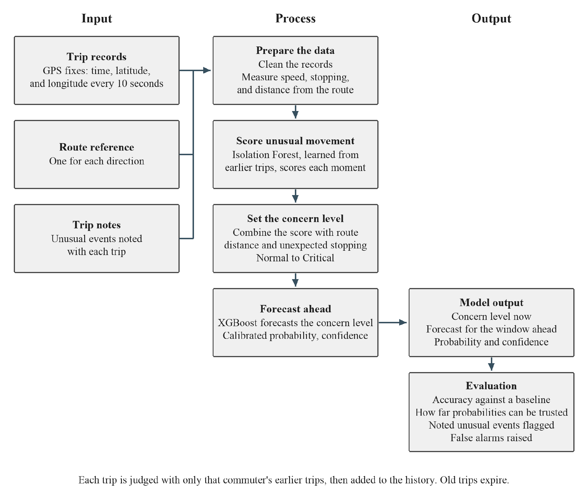
Figure 1. Conceptual framework of the study

CHAPTER 3
METHODOLOGY
3.1 Introduction
This chapter explains how the study was planned. It starts with the research design, which has three parts that match the three objectives. It then describes the study setting, the participants, and how the sample was chosen. The next three sections follow the objectives in order: data gathering and preprocessing (Objective 1), model development (Objective 2), and model evaluation (Objective 3). The chapter ends with the tools used and the ethical steps taken. Each setting that has a number is given with the reason for it. Table 3.1 at the end of the chapter lists them all in one place.
3.2 Research Design
This study employs experimental and developmental research design with three parts, one for each objective. The first part is data gathering and preprocessing. Volunteer commuters record GPS trips with the prototype app, the records are cleaned, and they are turned into measures of speed, stopping, and distance from the route. This part belongs to the research design because the later parts can only be as good as the data they receive, and the choices made here, such as the recording interval and the cleaning limits, set what the Model can see. The second part is model development. The Model learns what is normal for each commuter from that commuter's earlier trips, scores how unusual each moment is, sets a concern level, makes labels from the unlabeled trips, and forecasts the level over a short forecast window. The third part is model evaluation. The recorded trips are replayed in the order they were recorded, as if each trip were happening for the first time, and the Model is judged on forecast accuracy, how far its probabilities can be trusted, the noted events it flags, and its false alarms. There is one Model, with the same settings for every commuter. What differs is the data it receives: each commuter has an independent history, so the Model learns from, and is judged on, that commuter's own trips. Each part uses what the one before it produced. Figure 2 shows the three parts and the steps in each.
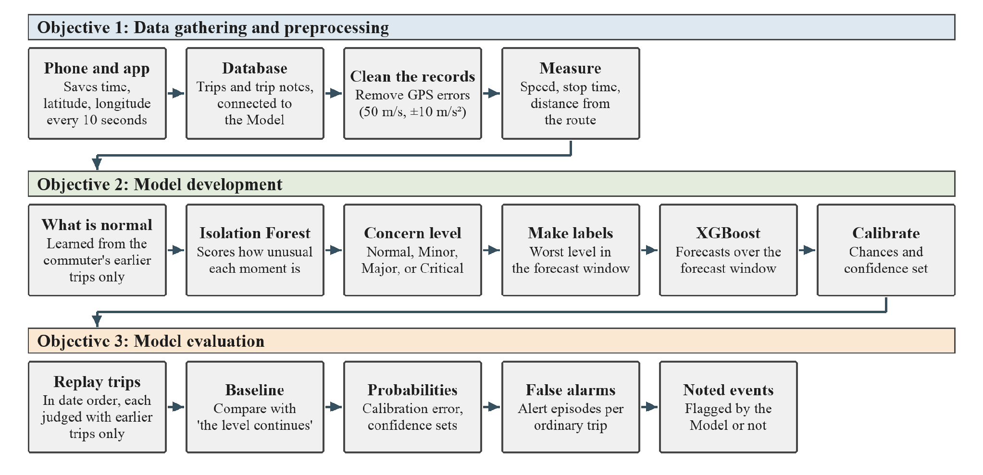
Figure 2. The three parts of the study and the steps in each.
The replay follows the advice of Roberts et al. (2017) and Hyndman and Athanasopoulos (2021), who say that data connected by time should be tested by learning from earlier records and judging on later ones. The study does not follow commuters after the trips, and it does not use incident reports. Safety incidents are scarce and many are never reported (Corpuz et al., 2023). The Model therefore learns what is normal from the trips themselves. Its output shows that a trip looks unusual. It does not show that anything harmful has happened.
3.3 Study Setting, Participants, and Sampling
3.3.1 Study Setting
The study takes place in Ilocos Norte. Trips are recorded on local transit routes in the province. The study is not limited to one kind of vehicle. Any public transport vehicle on a chosen route can be recorded, such as a jeepney, a tricycle, a bus, or a van, because the app saves only the position of the volunteer's phone and does not depend on the vehicle. Each volunteer notes the vehicle type for every trip, because vehicles can differ in how they travel. Some are faster than others, some stop more often or for longer to pick up passengers, and some may take slightly different roads on the same route. These differences change how long a trip takes and what a normal stop looks like. Noting the vehicle type lets the results be checked for each type, and it shows whether a stop or a slow stretch that looks unusual is simply normal for that kind of vehicle. If trips from different vehicle types are mixed in one history, the Model learns one idea of normal for all of them. A stop that is unusual for a bus may look normal because a tricycle often stops there, so the Model may miss it. This is a limit of the study. Each volunteer rides their own usual route. A commuter's route has its own route reference, and each commuter has an independent trip history. The trips of one commuter never enter the history of another.
3.3.2 Participants
The participants are volunteer commuters. Each volunteer records trips on a route they already ride. To take part, a volunteer must be an adult, must ride one of the chosen routes regularly, must own a smartphone that can run the prototype recording app, and must give informed consent. Researchers do not record trips, so the data come from ordinary commuting and not from trips made only for the study.
3.3.3 Sampling Method
The study uses purposive sampling. In this method, participants are chosen because they have the characteristics the study needs (Etikan et al., 2016). Here the needed characteristic is regular riding on a chosen route. This method has a limit: because the sample is chosen on purpose, it may not represent all commuters in the province (Etikan et al., 2016). The results are therefore reported for the routes and volunteers studied.
3.3.4 Sample Size and Recording Period
The sample is counted in trips, because the Model learns from trips and not from people. Two things decide how many trips are needed.
The first is seeing an unusual event at least once. Viechtbauer et al. (2015) give a simple formula for the number of trips needed:
$n = \frac{ln(1 - γ)}{ln(1 - π)}$ (3.1)
where n is the number of trips needed, γ is the confidence that the event is seen at least once, and π is the chance that the event happens on one trip. With the example values of the authors, a 5% chance on one trip (π = 0.05) and 95% confidence (γ = 0.95), the working is:
$n = \frac{ln(1 - 0.95)}{ln(1 - 0.05)} = \frac{ln(0.05)}{ln(0.95)} = \frac{-2.9957}{-0.0513} ≈ 58.4$ (3.2)
Rounded up to a whole trip, about 59 trips are needed. Because each commuter has a personal history, these trips are needed from every volunteer. The study therefore records at least 60 trips from each volunteer, 30 in each direction. This keeps the two directions equal, and each direction has its own route reference and history. The first results use one volunteer with 60 trips recorded over about 30 days. More volunteers are added later, each with at least 60 trips, so that the study can show the Model works for more than one person and on more than one route. If unusual events turn out to be rarer than 5% of trips, the number of noted events will be small. In that case the study reports them as counts and does not claim a detection rate.
The second is having enough history to learn from. Silvey and Liu (2024) show that the amount of data a model needs can be judged by following performance as the amount of training data grows. The study does this too, and its smallest history is five earlier trips and its largest is the full set for one commuter's route direction. Having 30 trips per direction allows the largest history groups to be compared with the smallest.
Trips and days are used for different things in this study. The number of trips decides how much the Model has to learn from. The number of days decides how old that history is allowed to be. The two are linked by how often trips are recorded. The plan is about one trip in each direction on each recording day, which is two trips a day on a route. At that rate, 60 trips take about 30 recording days.
The recording period must be longer than the longest history length that is compared. The study compares keeping all earlier trips with keeping only the last 14 or 7 days (Section 3.6.4). In the first 14 days, a 14-day window leaves nothing out, so it cannot be told apart from keeping all trips. A recording period of about 30 days therefore lets about half of the judged trips be judged with a window that really leaves out older trips. At the planned rate of a trip in each direction on each day, 30 days also gives the 60 trips needed. Volunteers record the trips they already make, so the study does not assign them to routes. A commuter's history then reflects that person's own usual vehicles, drivers, and times of day, which is what the Model should learn for that person.
More than two trips may be recorded on one day. They are all kept, and the history then holds more trips for the same number of days. A short window such as 7 days would then contain more trips than it would at two a day. For this reason the evaluation reports both: the number of earlier trips in the history for every judged trip (Section 3.6.3), and the number of days the history covers (Section 3.6.4).
3.4 Data Gathering and Preprocessing (Objective 1)
3.4.1 The Recording App
The prototype recording app saves three things for every record: the time, the latitude, and the longitude. These are the same three parts that Edwards and Hosein (2025) saved on a phone for each trip. The app is only a way to collect data. The study does not test the app itself, such as how easy it is to use or how much battery it uses.
3.4.2 Recording Interval
The app saves one position every 10 seconds. This is short enough to catch the stops this study cares about. Sabir et al. (2025) describe pauses under 40 seconds as brief, and a 40-second stop has about four records at 10 seconds. It is also much finer than the 30 to 60 seconds common in coach GPS, which Deng et al. (2024) say is too long to tell whether a vehicle has stopped. Bagheri et al. (2020) and Mears et al. (2021) also used 10 seconds for smartphone travel data. Edwards and Hosein (2025) note that polling every second uses more battery, which is a reason not to use the shortest interval.
3.4.3 Recording Procedure
A volunteer starts the app when boarding and stops it on arrival. The app is connected to a database, and the records of each trip are sent there. Each trip is stored with the volunteer's code, the route, the direction, the vehicle type, and the date. The database is connected to the Model, so the Model reads the trips of each commuter straight from the database and is fitted on them as that commuter's history grows. The trips of each commuter are kept together, with one set for each direction, as in the test data used to build the tools.
3.4.4 Route Reference
Each commuter's route has a route reference for each direction, which is the road line that vehicles usually follow from start to end. It is drawn on the map for the route and is used to measure how far along the route a vehicle is and how far it is from the usual road. Edwards and Hosein (2025) also compare positions with a saved route. Figure 3 shows the route reference of the first route. Point A is where the recorded trips start and point B is where they end.
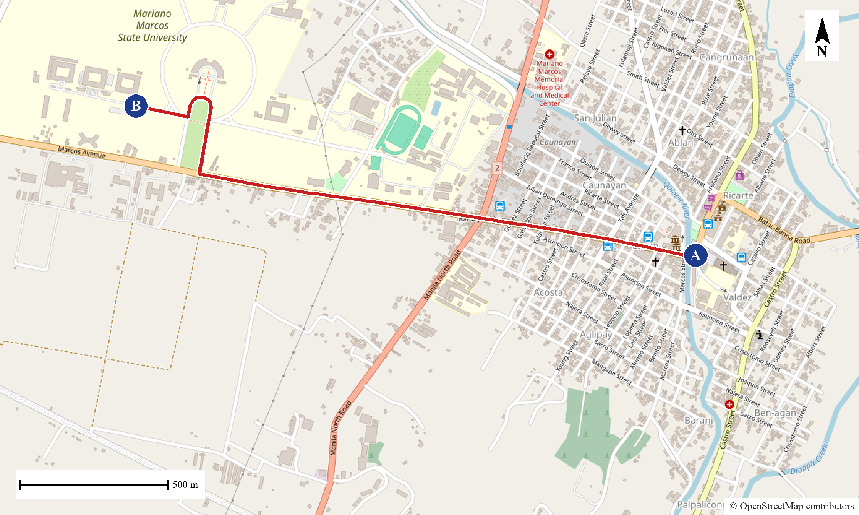
Figure 3. Route reference of the first route. Point A is the start of the recorded trips and point B is their end. Map data © OpenStreetMap contributors.
3.4.5 Trip Notes
The trip notes are written inside the app. After each trip, the app shows the volunteer a short form. The form asks whether anything unusual happened and, if so, what kind of event it was (a long unexpected stop, leaving the usual route, feeling unsafe, or another event), about when it happened, and a line of description. The app sends the notes to the database together with the trip, so the Model reads the notes with the trip they belong to. These notes are the only labels the study has, and they are kept apart from the model building. They are used only in the evaluation to check whether the Model flagged the noted events (Section 3.6.2). Sørbø and Ruocco (2024) show that the way unusual events are counted changes the results, so the notes ask for a time and the evaluation counts an event only inside a stated time window.
3.4.6 Cleaning GPS Errors
Each file is cleaned before anything else, because preprocessing comes early in the process (Zheng, 2015). First, rows with a missing or unreadable time, latitude, or longitude are removed, the rows are put in time order, and repeated times are removed. Second, if the file has an accuracy column, records with a reported error radius above 50 m are removed. Third, a record is removed if it implies a move faster than 50 m/s from the last kept record. Fourth, a record is removed if it implies an acceleration outside the range of -10 to 10 m/s². The speed, accuracy, and acceleration limits come from Verma et al. (2024). The speed and acceleration checks are repeated until no record breaks a limit. At a 10-second interval the acceleration limit is rarely reached, and the speed limit does most of the work. A speed of 50 m/s is 180 km/h, far above the highest limit of 80 km/h in the Land Transportation and Traffic Code (1964).
The study records how many records were removed by each rule for every trip. A trip is set aside if it loses more than one record in five or has fewer than 20 records left, because it can no longer be followed reliably. The list of trips set aside, and the reason for each, is reported with the results so that the rule can be reviewed.
3.4.7 Measuring Speed, Stops, and Distance from the Route
From the clean records, the following measures are worked out for every moment of a trip. Speed is the distance between two records divided by the actual time between them, which avoids errors when a record is late or missing. Acceleration and turning come from the changes in speed and direction. A vehicle counts as stopped when its speed is below 5 km/h, the low-speed limit used by Sabir et al. (2025). Stop time is how long it has stayed below this speed.
Every position is projected onto the route reference for its direction. This gives the route progress, which is how far along the route the vehicle is, and the distance from the route line. This is similar to the map matching of Newson and Krumm (2009). The study also measures the shortest distance between the position and the positions of earlier trips on the same route, as Edwards and Hosein (2025) did. Speed, stopping, and route distance are also summarised over the minute before each moment, The look-back stays at one minute, even when the forecast window is changed. Figure 4 shows route progress and the distance from the route for one position.
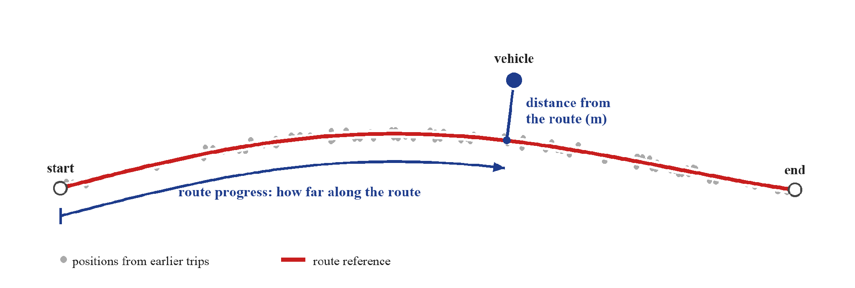
Figure 4. Route progress and distance from the route for one position of a vehicle (illustration).
3.5 Model Development (Objective 2)
3.5.1 What Is Normal for Each Place and Time
The Model first learns what is normal for a commuter from that commuter's own earlier trips. It divides each route direction into stretches of road. For each stretch, and for each part of the day, it learns the usual speed and how much speed varies. What is normal depends on the place and time, as in iBOAT (Chen et al., 2013) and in the stop comparison of Sabir et al. (2025). The day is split into four parts: night, morning, midday, and afternoon. Night is kept apart because UN Women (2021) found that safety worries are much higher at night. The split is also tested: Section 3.6.5 compares the four parts with a split into night and day only and with no split at all. Where a stretch has few trips in one part of the day, the Model leans on the all-day figure for that stretch. The first stretch length is 100 m, and the Model leans on the all-day figure with a strength of 8 trips. No source gives these values, so Section 3.6.5 tests other values around them.
3.5.2 Scoring Unusual Movement with the Isolation Forest
An Isolation Forest (Liu et al., 2008) gives each moment a score for how easy it is to separate from the rest. Liu et al. found that 100 trees built on samples of 256 points were enough, and this study uses the same settings. Two forests are built, each from half of the history trips. A history trip is scored by the forest that did not see it, and a new trip gets the average of both. This stops the Model from scoring trips it has already memorised, which would make the scores look too normal. Cawley and Talbot (2010) warn about the same problem of judging on data that was used to build the model. Scores are smoothed over 30 seconds so that a single odd record does not decide the level. Figure 5 shows how this works.
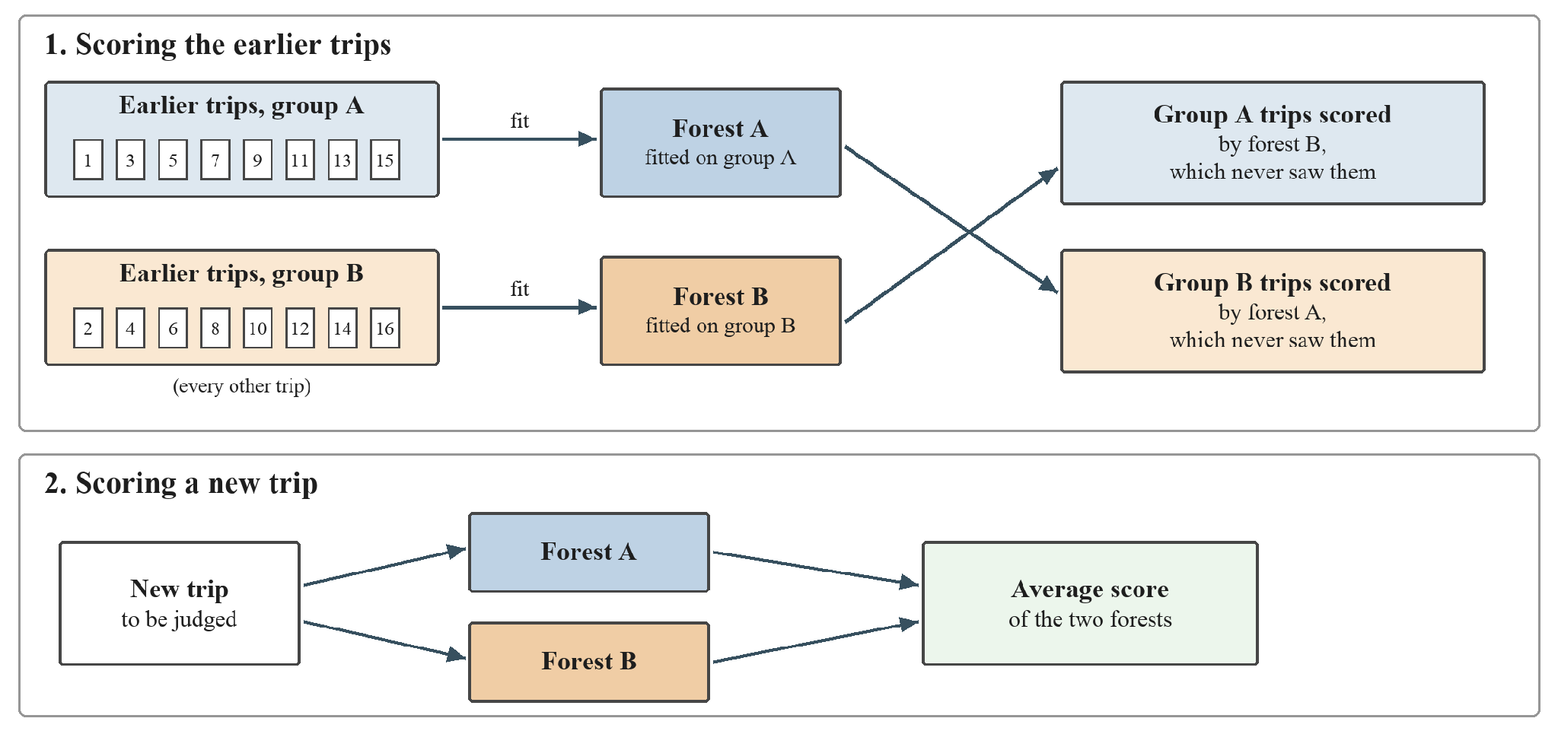
Figure 5. How the two Isolation Forests score the earlier trips and a new trip.
3.5.3 Setting the Concern Level
Each moment gets the highest of three levels. The first level comes from the forest score. The second comes from the distance from the route: up to 150 m is Normal, up to 500 m is Minor, up to 1,000 m is Major, and beyond 1,000 m is Critical (Edwards & Hosein, 2025). While the commuter has fewer than 5 earlier trips in that direction, the distance is measured from the route line. After that, it is measured from the commuter's earlier trips, so a detour that the commuter makes often becomes familiar and counts as Normal. The number 5 has no source, so it is treated as an experiment in Section 3.6.5. The third level comes from how long the vehicle has been stopped.
The forest score and the stop time are turned into levels with a robust score. This measures the distance from the median in units of the median absolute deviation, so that a few extreme trips do not distort it. The forest score is compared with the scores of the history. The stop time is compared with the lengths of stops that finished in the history, so a stop is judged against what is usual for the route and not against a fixed number of seconds, as in Sabir et al. (2025). Leys et al. (2013) recommend 2.5 as a cut-off, and Iglewicz and Hoaglin recommend labelling scores above 3.5 as potential outliers (as cited in NIST/SEMATECH, n.d.). The levels Minor, Major, and Critical start at robust scores of 2.5, 3, and 3.5, so Major lies halfway between the two recommended values. Figure 6 shows how the three levels are combined, with an example.
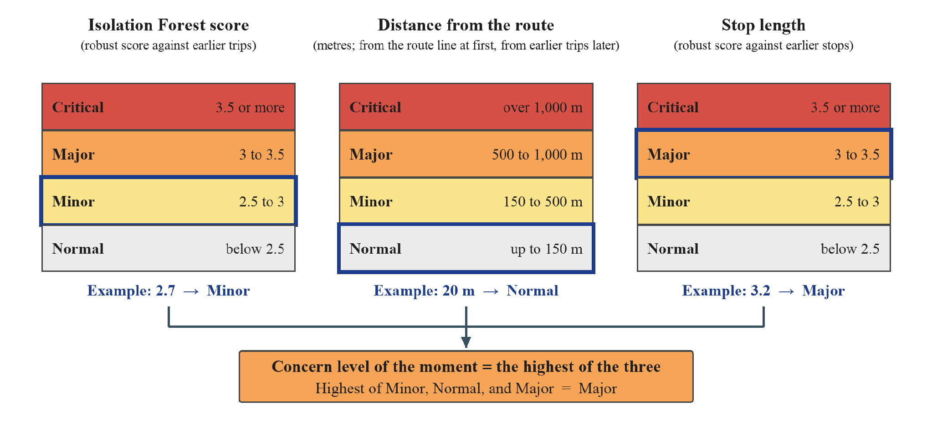
Figure 6. How the concern level is set from the forest score, the distance from the route, and the stop length (illustrative values).
3.5.4 Making Labelled Data from Unlabeled Trips
XGBoost learns from examples that come with an answer. The labels are made after the concern level is set, because they are built from it. The recorded trips have no answers, because nobody marks which moments were unusual. The study therefore makes the answers from the trips themselves, in four steps. Bakker et al. (2025) and Yuan et al. (2024) also made labels from unlabeled data to train supervised models.
First, every moment of a trip gets a concern level from Normal to Critical (Section 3.5.3). Second, for each moment, the Model looks at the forecast window, which is the short time that comes after it. Third, the label of the moment is the worst concern level found in that window. Fourth, the measures at the moment (Section 3.4.7), such as speed, stop time, and distance from the route, are the input, and the label is the answer that XGBoost learns to predict. Near the end of a trip, less than the forecast window remains, so the label uses the records that are left.
Figure 7 shows an example from one trip in the test data. The records on the left have only the time, the latitude, the longitude, and the Isolation Forest score. On the right, the speed, the stop time, and the distance from the route are added as inputs, and each moment has its label. For example, at 09:08:09 the vehicle is moving at an ordinary 28.9 km/h with no stop, but the label is Major because the vehicle stops soon after. In this way, XGBoost learns what the moments before a long stop tend to look like.
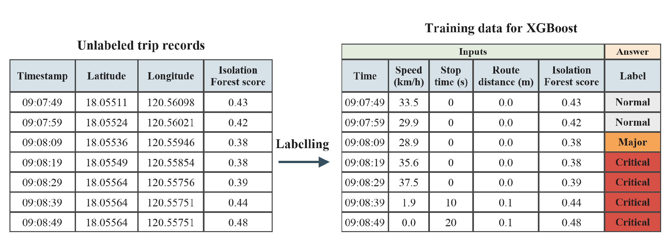
Figure 7. Making labelled data from unlabeled trip records (example rows from one trip in the test data).
The forecast window starts at one minute, because a forecast has to arrive in time for a check-in. In SayfTrip, when a route deviation reaches the critical level, the user has 30 seconds to answer before a message goes to an emergency contact (Edwards & Hosein, 2025), so a window shorter than that would leave no time for that step. No study reviewed gives the best length, so the window is treated as an experiment and compared in Section 3.6.5. A longer window gives more warning, but it may make the forecast less accurate. The labels show what looks unusual compared with earlier trips. They do not show what was dangerous.
3.5.5 Forecasting with XGBoost
XGBoost (Chen & Guestrin, 2016) forecasts the worst concern level in the forecast window from the measures at each moment and the concern level now. It suits tables of measures such as speed and stopping time. The levels are ordered, so the problem is turned into three yes-or-no questions: is the worst level in the forecast window at least Minor, at least Major, and at least Critical? Frank and Hall (2001) show how to combine such answers into an ordered prediction. The three chances are kept in order, so a higher level never gets a higher chance than a lower one. The number of trees is chosen by early stopping on held-out trips. The other settings are kept small for a small data set, with shallow trees and a low learning rate, and are listed with the code. Figure 8 shows the three questions and how the latest earlier trips are held out (Section 3.5.6).
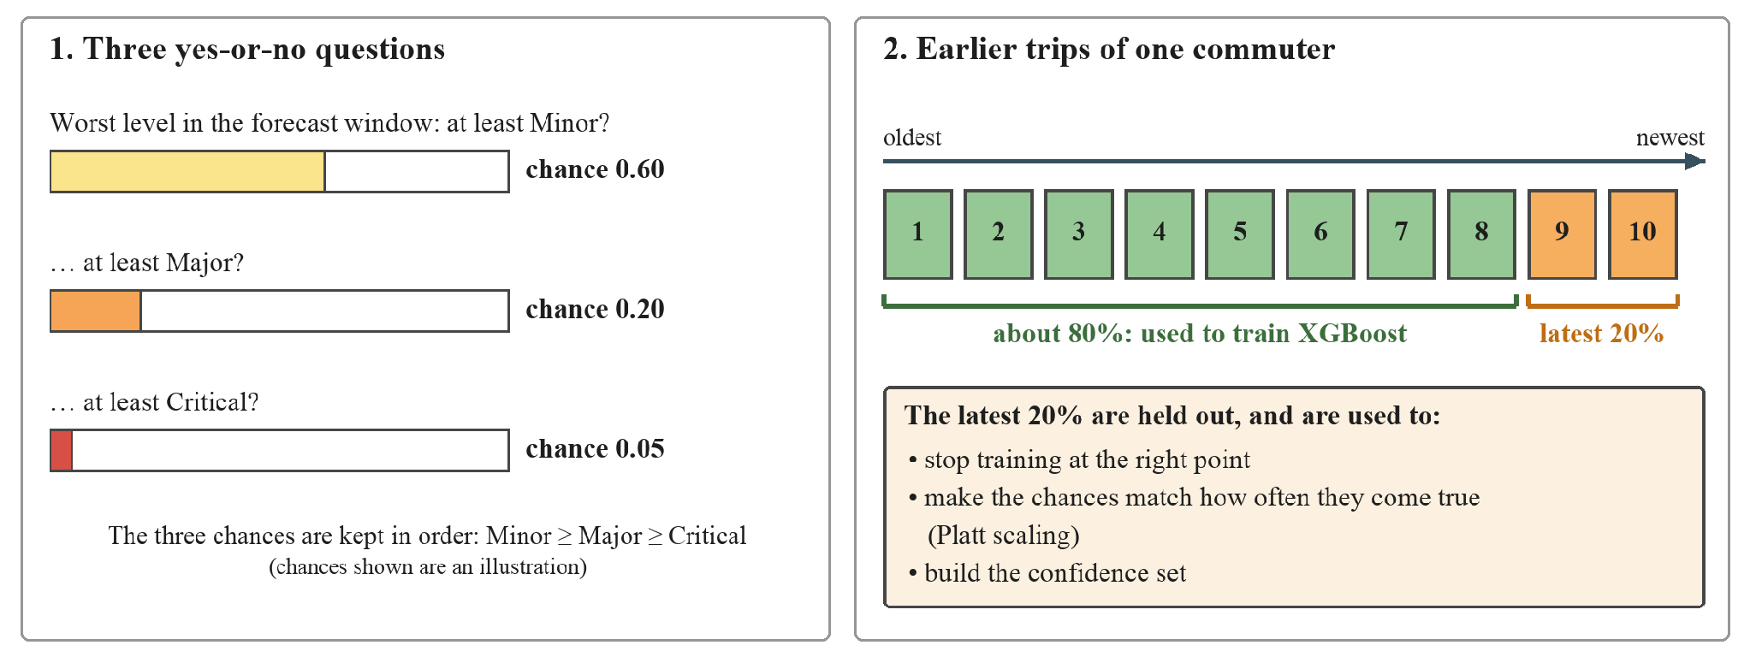
Figure 8. The three yes-or-no questions of XGBoost and the use of the latest 20% of earlier trips (illustrative chances).
3.5.6 Calibration and Confidence
The latest 20% of the history trips, and at least two trips, are held out when the Model is built. Hyndman and Athanasopoulos (2021) say a test set is typically about 20% of the sample, and this study uses the same share as a guide. These trips are used for early stopping, for calibration, and for the confidence sets. Boosted trees tend to give distorted probabilities, and Platt scaling improves them (Niculescu-Mizil & Caruana, 2005), so the chances from the three questions are calibrated with Platt scaling on the held-out trips. Guo et al. (2017) call the gap between confidence and how often a model is right the calibration error, and the study reports it.
The Model also gives a confidence set, which is a short list of levels that contains the true level at a chosen rate. This is split conformal prediction (Angelopoulos & Bates, 2021). The target rate is 90%, a common choice in conformal prediction. The cut-off is taken from the held-out trips.
3.5.7 Keeping the History Recent
Roads, routes, and traffic change, so very old trips may no longer show what is normal. Gama et al. (2013) found that forgetting old data helps a learner follow change, either with a window of recent examples or with weights that fade. The Model uses a window. It learns only from the same commuter's earlier trips that fall inside a chosen number of days before the trip being judged. The best length is not known in advance, so the study tests several lengths (Section 3.6.4).
3.6 Model Evaluation (Objective 3)
3.6.1 Testing Trip by Trip in Date Order
The trips are put in order by start time. Each trip is judged by the Model fitted only on the same commuter's trips before it, and never on another commuter's trips. After it is judged, the trip joins that commuter's history for the next one. A trip is never split between building and judging, because records from the same trip are closely related (Roberts et al., 2017). This is the prequential idea of Gama et al. (2013): each new example is first used to test the model and then to update it. A trip is judged only when at least five earlier trips are available. The study judges this way for the whole recording period. The results are worked out separately for each commuter and then summarised across commuters, with the lowest and highest values shown, so that no single commuter decides the average alone. Figure 9 shows which earlier trips are used in three cases.
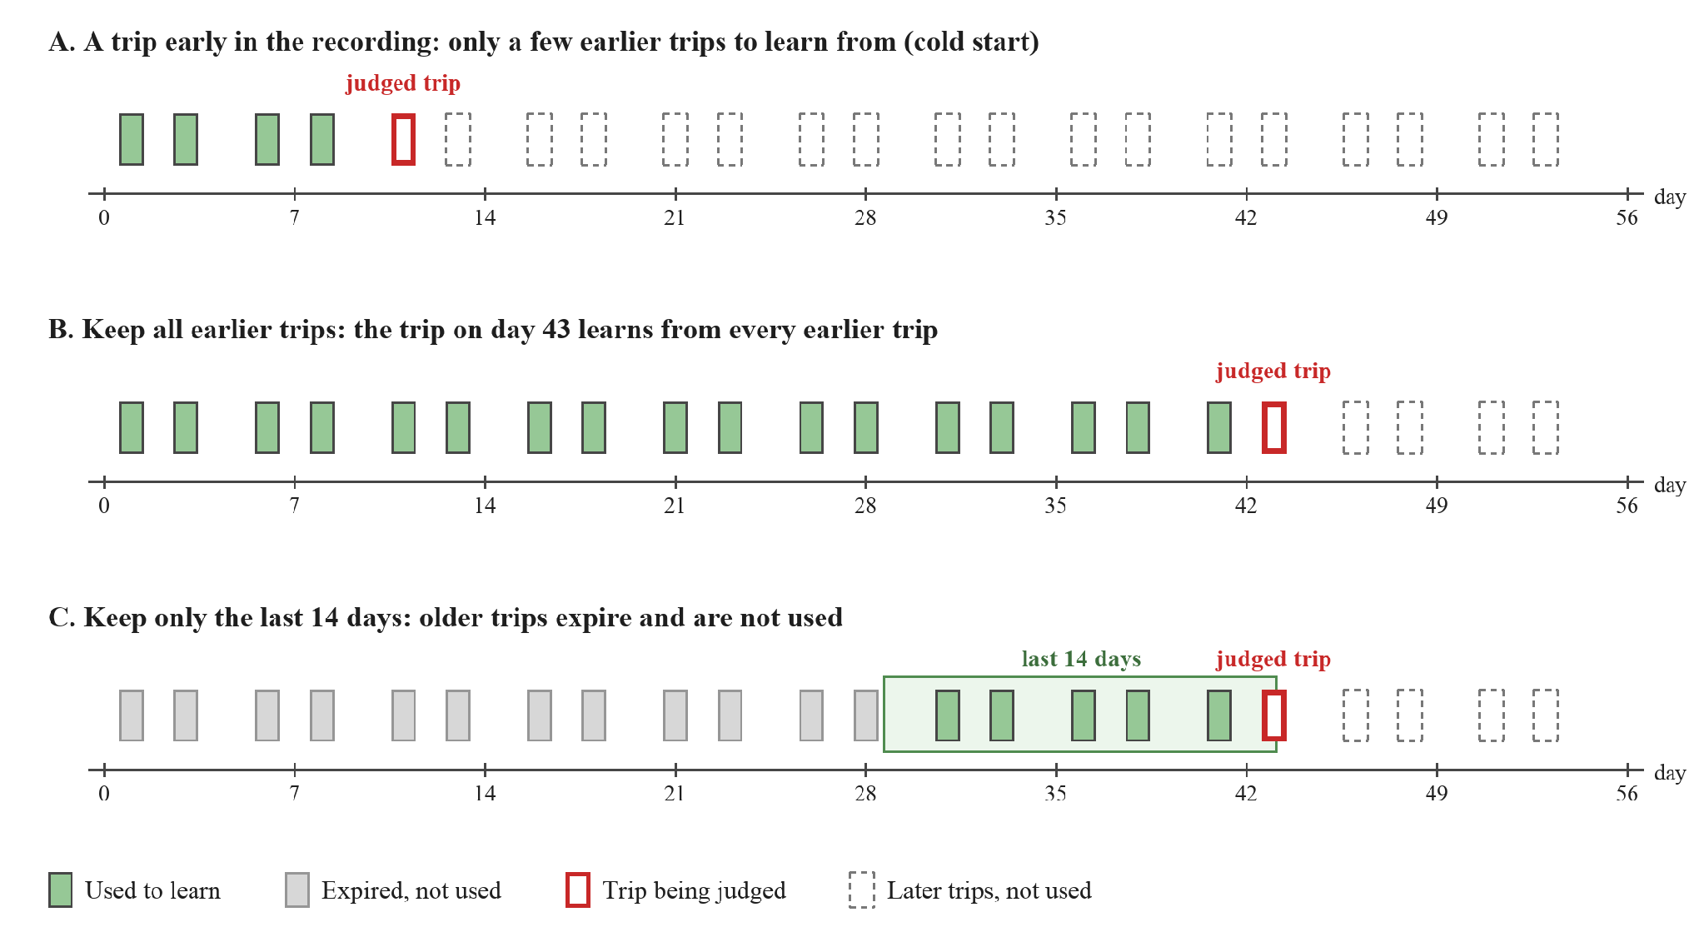
Figure 9. Which earlier trips are used to judge a trip: early in the recording, keeping all earlier trips, and keeping the last 14 days (illustration; not every trip is shown).
3.6.2 Baseline and Noted Events
The forecast is compared with a simple baseline that assumes the current concern level continues. Both are scored with average precision, which rewards ranking real concerns above ordinary moments, for the questions "at least Minor" and "at least Major". The average gap between the forecast level and the true level is also reported. For each of the two questions, the study also reports the share of unusual moments that an alert caught and the share of alerts that were right. For "at least Minor", an alert from the forecast means a chance of at least 0.5 of Minor or worse, and an alert from the baseline means that the current level is Minor or higher.
The notes from the volunteers are used to check the noted events. A noted event counts as flagged if the Model raises an alert from two minutes before to two minutes after the noted time. The window allows for a volunteer's time estimate being rough. It is a starting value, so the study also reports one minute and three minutes. An alert is raised when the forecast chance of a level of Major or worse is at least 0.5, the plain midpoint. This is a starting value, and Section 3.6.5 compares lower limits. The study reports how many noted events were flagged by the forecast and by the current level, and how far ahead the first alert came. Without enough noted events, this check is reported as counts only.
The study also asks whether the forecast gives earlier warning than reacting to the current level. For each trip where both the forecast and the current level reach an alert, it measures how many seconds earlier the forecast alerted. It also counts the trips where both alerted, where only the forecast alerted, and where only the current level reached the alert level. These counts show how often the forecast agrees with the current level and how often it adds or misses something.
3.6.3 History Growth
To show how the Model behaves at the start, the judged trips are grouped by how many earlier trips were in the history, such as 5 to 9, 10 to 19, and so on. For each group, the study reports forecast accuracy against the baseline, calibration error, confidence-set coverage, and false alarms. This is a learning curve in the sense of Silvey and Liu (2024). It also shows the cold-start problem described by Reiss et al. (2024).
3.6.4 History Length
The study compares three history lengths on the same trips: all earlier trips, and only the last 14 or 7 days (see Figure 9 for the 14-day case). For each, it reports the same measures as above. The length with the fewest false alarms and no loss of accuracy is chosen. Cawley and Talbot (2010) warn that settings chosen on the same data used to judge them can look better than they are, so the chosen length is confirmed on new trips recorded after the choice was made.
3.6.5 Checking the Starting Values
Seven starting values have no direct source: the forecast window of one minute, the 100 m stretch length, the strength of 8 trips, the four parts of the day, the 5 earlier trips before the route distance switches from the route line to the earlier trips, the alert limit of 0.5, and the 20% of earlier trips held out for calibration. They are treated as experiments. The study repeats the evaluation with forecast windows of 30 seconds and 2 minutes, with stretch lengths of 50 and 200 m, with strengths of 4 and 16 trips, and with the day split only into night and day or not split at all. For the route distance, it also compares switching after 3 and after 10 earlier trips, and the earlier rule that takes the larger of the distance from the route line and from the earlier trips. It also compares holding out 10% and 30% of the earlier trips, and alert limits from 0.1 to 0.4. The alert limit changes only the alerts and not the accuracy scores, so it is compared by the share of unusual moments caught, the share of alerts that were right, and the false alarms per hour. Changing the forecast window also changes the labels, so the results for different settings are compared by the gain, which is how far the forecast's average precision for Major or worse is above the baseline's, together with the calibration error, the false alarms per hour, and the lead over the current level. If the results change little, the starting values are kept. If they change a lot, the values are re-chosen on the earlier trips only and then confirmed on new trips.
3.6.6 Probabilities and Confidence
The study reports the calibration error for the chance of "at least Minor" and "at least Major". It uses equal-width bins of predicted chance. Guo et al. (2017) use 15 bins, and this study uses 8 so that each bin has enough records with a small data set. It also reports the share of moments for which the confidence set contained the true level, and the average size of the sets, and compares the share with the 90% target.
3.6.7 False Alarms
False alarms are counted on ordinary trips, which are the trips with no noted event. Alerts less than one minute apart are counted as one alert episode, which is the starting forecast window. The study reports the number of alert episodes per ordinary trip, the share of ordinary trips with at least one alert, and the number of alert episodes per hour of travel, for the forecast and for the baseline. This follows the concern of Edwards and Hosein (2025) and Cvach (2012) that too many false alarms teach people to ignore warnings.
3.6.8 Route Familiarization
To show that the Model learns a commuter's usual detours, the study takes the trips that go beyond 150 m of the route line and have at least 20 earlier trips in the same direction. It counts the moments beyond 150 m when the distance is measured from the route line, and when it is measured from the most recent 2, 5, 10 and 20 earlier trips. The fewer moments remain, the better the earlier trips describe the commuter's own paths.
3.6.9 A Fixed Distance Rule for Comparison
The forecast is also compared with a fixed rule that alerts whenever the vehicle is more than 150 m from the route line, which is the first level of the fixed bands in SayfTrip (Edwards & Hosein, 2025). The study counts the alert episodes per trip and per hour for both. It also counts how many long stops and how many episodes beyond 150 m each one flags. A long stop is a finished stop of 40 seconds or more, the length that Sabir et al. (2025) call brief. A rule flags a stop or an episode if it alerts from one minute before it starts to its end. Without trip notes, this comparison shows what each rule watches for, and not which alerts were right.
3.6.10 A Simpler Model for Comparison
XGBoost may be more than a small data set needs, so its forecast is compared with a plain logistic regression. This is a simple method that draws a straight boundary between moments that were followed by an unusual window and moments that were not. It uses a small set of the same inputs: the concern level now, the Isolation Forest score, the stop time and the excess stop time, the time off the route, the distance from the route, the speed, the speed trend, the time since the last stop, the stops in the last minute, and the speed score. It uses the same labels, the same calibration, and the same trips as XGBoost. The comparison asks whether the extra complexity of XGBoost is worth it for the amount of data available.
3.6.11 Other Checks
Three more checks make the results easier to read. The study shows which part of the concern level, the Isolation Forest score, the route distance or the stop length, set each level. It reports the results for each direction of the route. It also measures how long the Model takes to fit on the earlier trips and to score a trip, to see whether it is quick enough to be refitted after every trip.
3.7. Objective 3
3.8 Ethical Considerations
Recording trips involves personal data. Under the Data Privacy Act of 2012 (Republic Act No. 10173), consent must be freely given, specific, and informed. Every volunteer is told what is recorded, why, who can see it, and how long it is kept, and signs a consent form before recording. Volunteers can stop at any time and ask for their records to be removed. Riders who share the vehicle are not recorded, because the app saves only the volunteer's own position. Files carry a volunteer code and not a name. The records are stored in the database, which only the researchers can open, and they are kept only as long as the study needs them. The study will ask for approval from a research ethics committee before any recording begins.
Start and end positions can show where a person lives or works. To lower this risk, results are reported for routes and not for people, and the maps in the report show only the public start and end places of a route and never a volunteer's home.
3.9 Summary of Settings
Table 3.1 lists each setting used in this chapter, its value, and where the value comes from. Settings marked as design choices have no source. They are chosen for simplicity, and the study reports them with the results so that they can be reviewed.
Table 3.1 Settings used in the study and their basis
Setting | Value | Basis
Recording interval | 10 seconds | Sabir et al. (2025); Deng et al. (2024); Edwards & Hosein (2025); Bagheri et al. (2020); Mears et al. (2021)
Speed limit for cleaning | 50 m/s | Verma et al. (2024); Land Transportation and Traffic Code (1964)
Acceleration limit | -10 to 10 m/s² | Verma et al. (2024)
Error radius limit | 50 m | Verma et al. (2024)
Trip set aside | more than 1 record in 5 lost, or fewer than 20 records left | Design choice, reported with the results
Stopped speed | below 5 km/h | Sabir et al. (2025)
Route distance levels | 150, 500, and 1,000 m | Edwards & Hosein (2025)
Level cut-offs for forest score and stop time | robust scores of 2.5, 3, and 3.5 | Leys et al. (2013); NIST/SEMATECH (n.d.); Major is the midpoint
Isolation Forest size | 100 trees, samples of 256 | Liu et al. (2008)
Forecast window | starts at 1 minute; 30 seconds and 2 minutes are compared | Experiment. Edwards & Hosein (2025): a 30-second response time means a shorter window leaves no time (Section 3.6.5)
Held-out share of history | latest 20%, at least 2 trips; 10% and 30% are compared | Starting value after Hyndman & Athanasopoulos (2021); experiment (Section 3.6.5)
Confidence set rate | 90% | Angelopoulos & Bates (2021) for the method; 90% is a common choice
Trips per volunteer | at least 60, 30 per direction | Viechtbauer et al. (2015): 59 trips at 5% and 95%
Recording period | about 30 days for each volunteer | So that about half of the judged trips come after day 14, when a 14-day window starts to leave out older trips; also gives 60 trips at two a day
History lengths compared | all, 14, and 7 days | Compared in the study (Section 3.6.4)
Road stretch and strength | 100 m and 8 trips | No source; 50 and 200 m, and 4 and 16 trips, are tested (Section 3.6.5)
Earlier trips before the route distance uses them | 5; 3 and 10, and the larger-of-both rule, are compared | Experiment (Section 3.6.5)
Parts of the day | night, morning, midday, afternoon; night and day only, and no split, are compared | Experiment (Section 3.6.5). Night is kept apart because of UN Women (2021)
Fewest earlier trips before judging | 5 | Design choice, reported with the results
Look-back for the measures | 1 minute | Design choice; stays fixed when the forecast window changes
Alert rule | chance of Major or worse of at least 0.5; limits from 0.1 to 0.4 are compared | Plain midpoint as the starting value; experiment (Section 3.6.5)
Alert episode gap | 60 seconds | Starting forecast window; design choice
Event window for noted events | 2 minutes before to 2 minutes after; 1 and 3 minutes also reported | Experiment; reported with the results
Calibration bins | 8 | Guo et al. (2017) use 15; fewer bins suit a small data set

CHAPTER 4
INITIAL RESULTS AND DISCUSSION
4.1 Introduction
This chapter reports the first results of the study. They are called initial because they come from the trips of one commuter only, and because the trip notes have not been collected yet. The chapter follows the three objectives. It first describes the data and how they were prepared (Objective 1). It then shows what the Model produced (Objective 2). It ends with the tests of the Model (Objective 3). Each section gives the results first and then says what they mean in plain words.
The numbers are small and come from one person, so they show whether the method works and where it is weak. They do not show how well it would work for commuters in general. Three measures are used again and again. Average precision tells how well a forecast puts the moments that really became unusual above the ordinary ones, and a higher value is better. Calibration error tells how far the stated chances are from how often they come true. If the Model says 30% many times, about 30% of those moments should turn out unusual, and the calibration error is the average gap, so 0.03 means about 3 points. A lower value is better. A false alarm is an alert that is not followed by a real concern. Alerts that are less than one minute apart are counted as one false alarm episode. Because no trip has a note yet, every trip is counted as an ordinary trip when false alarms are counted.
4.2 The Initial Dataset (Objective 1)
4.2.1 What Was Recorded
The initial dataset is the set of trips of one commuter on one route, in both directions. Table 4.1 describes it. The commuter recorded one trip in each direction on each of 30 recording days, which gives 60 trips and 2,936 records. The trips were recorded in the morning and in the afternoon. None was recorded at night.
Table 4.1. The initial dataset
Item | Value
Commuter | One
Trips | 60 (30 from A to B and 30 from B to A)
Records | 2,936, one every 10 seconds
Recording period | 18 August to 8 October 2026 (52 days)
Recording days | 30, with one trip in each direction on each day
Time of day | 29 trips in the morning (7:00 to 9:59), 3 at midday, 28 in the afternoon (14:00 to 17:59), none at night
Length of a trip | 8 minutes on average (from 5.5 to 11.2 minutes)
Distance of a trip | 2.6 km on average (from 2.2 to 3.6 km)
Speed while moving | Middle value 25.5 km/h (most records between 16 and 33 km/h)
Records with the vehicle stopped | 24%
Stops | 200 stops during the trips, about 3 per trip. The middle length is 30 seconds and the longest is 90 seconds. Each trip also starts with the vehicle standing still for 10 seconds.

4.2.2 Cleaning
No record broke the speed limit of 50 m/s or the acceleration limit, and there were no repeated times or unreadable rows. The file has no accuracy column, so the limit on the error radius was not used. No trip was set aside. The fastest speed in the data was 41 km/h, which is about 11 m/s and far below the 50 m/s limit, so the speed rule had nothing to remove. The cleaning rules therefore removed nothing from this dataset. To check that the rules work, a jump of about 15 km was added to a copy of one trip, and the speed rule removed that one record. This check was made on a copy and is not part of the dataset.
4.2.3 Trips That Leave the Route
The vehicles do not always stay on the route line. Of the 60 trips, 26 stayed within 150 m of the line all the time, and 34 went beyond 150 m at least once. An episode is one continuous stretch of time. An episode away from the route starts when the vehicle goes beyond 150 m of the route line and ends when it is back within 150 m. Together the 34 trips had 41 such episodes. An episode lasted from 10 to 140 seconds, with a middle value of 60 seconds. The largest distance was 393 m. This is in the Minor band (150 to 500 m), so no trip reached the Major band (500 to 1,000 m) or the Critical band.
Figure 10 shows two trips. Trip 17 stays within the limit. Trip 36 leaves the limit twice and returns each time. These departures happen in more than half of the trips, so for this commuter they are part of normal travel.
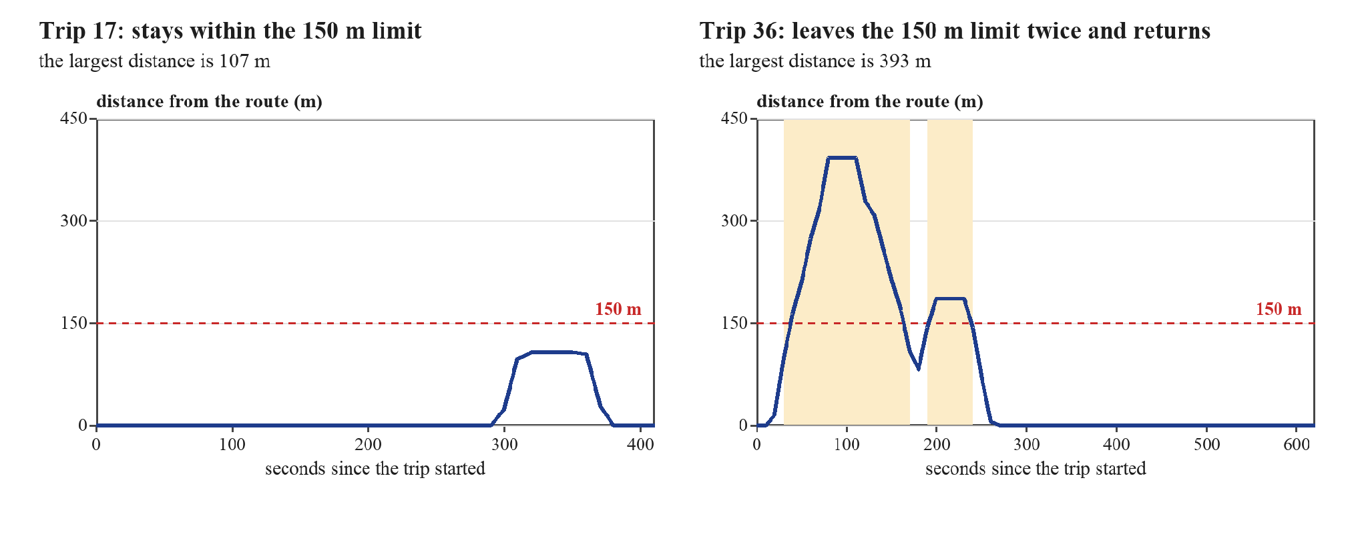
Figure 10. Distance from the route line over time for two trips (the shaded parts are beyond 150 m).
4.2.4 Route Familiarization
A commuter who takes the same detour again and again is doing nothing unusual. The Model handles this in the distance from the route. While the commuter has fewer than 5 earlier trips in a direction, the distance is measured from the route line. After that, it is measured from the commuter’s own earlier trips. Figure 11 shows the 30 trips from A to B. Most follow the route line, but several take the same few other paths, in the town near A and around the campus near B.
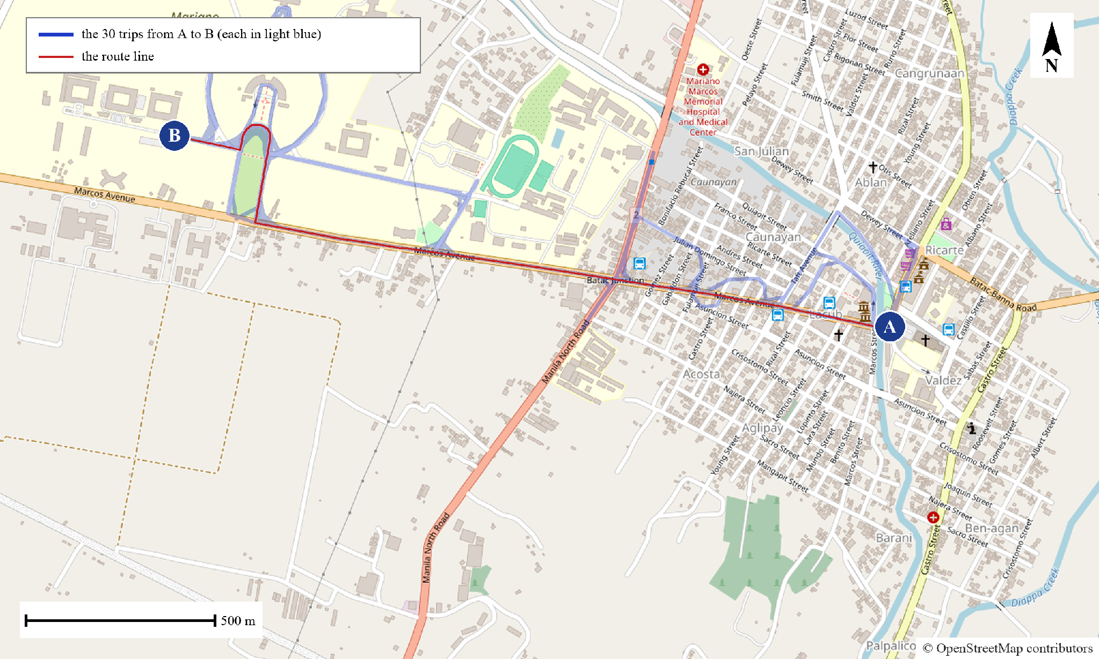
Figure 11. The 30 trips from A to B on the map, with the route line. Map data © OpenStreetMap contributors.
Table 4.2 shows what the earlier trips do. It uses the 11 trips that leave the 150 m limit and have at least 20 earlier trips in the same direction. Measured from the route line, these trips had 106 moments beyond 150 m. With only 2 earlier trips as the history, 56 moments were still beyond 150 m. With 5 earlier trips there were 18, and with 20 earlier trips only 7. This means that 83% of the moments away from the route line were already familiar after 5 earlier trips, and 93% after 20. The commuter’s usual detours stop counting as off-route once there is enough history.
Table 4.2. Moments beyond 150 m when the distance is measured from different histories
Distance measured from | Moments beyond 150 m | Share of the moments beyond the route line
The route line | 106 | 100%
2 earlier trips | 56 | 53%
5 earlier trips | 18 | 17%
10 earlier trips | 12 | 11%
20 earlier trips | 7 | 7%

4.3 The Model on the Initial Data (Objective 2)
4.3.1 Concern Levels
The Model gave every moment of every judged trip a concern level. Table 4.3 shows how often each level occurred. Most moments were Normal. The label of a moment is the worst level in the next minute, so labels reach higher levels more often than the levels at the moments themselves.
Table 4.3. Concern levels of the 2,727 judged moments
Level | Moments at that level now | Moments with that level as the label
Normal | 2,532 (93%) | 2,258 (83%)
Minor | 110 (4%) | 214 (8%)
Major | 41 (2%) | 106 (4%)
Critical | 44 (2%) | 149 (5%)

4.3.2 What Sets the Levels
The level of a moment is the highest of three parts: the Isolation Forest score, the distance from the route, and the length of the current stop. Table 4.4 shows which part reached the level. A moment is counted under more than one column when two parts reach the same level. Route distance reached only Minor, because no trip went beyond 500 m. The Major and Critical levels therefore came from the Isolation Forest score and from long stops, in about equal parts.
Table 4.4. The part that set the concern level
Level now | Moments | Isolation Forest score | Distance from the route | Stop length
Minor | 110 | 41% | 38% | 25%
Major | 41 | 49% | 0% | 51%
Critical | 44 | 39% | 0% | 61%

4.3.3 A Worked Trip
Figure 12 follows Trip 36 from start to end. The Model judged this trip using only the 35 trips recorded before it. The vehicle began to move away from the route at about 20 seconds and passed the 150 m limit at about 40 seconds, when the concern level rose to Minor. When the vehicle stopped at about 90 seconds, the level rose to Major and then to Critical. The level returned to Normal after the vehicle came back to within 150 m of the route.
The forecast did well in one way and badly in two. The chance of Minor or worse rose from 0.02 at 20 seconds to 0.40 at 30 seconds, ten seconds before the level itself rose, and it passed 0.5 at 50 seconds. But the chance of Major or worse stayed at zero during the whole first departure, even when the level was already Critical. Near the end of the trip, the vehicle stopped at about 450 seconds and the chance of Major or worse rose above 0.5. The stop ended before it became long, so Major was never reached and this alert was a false alarm.
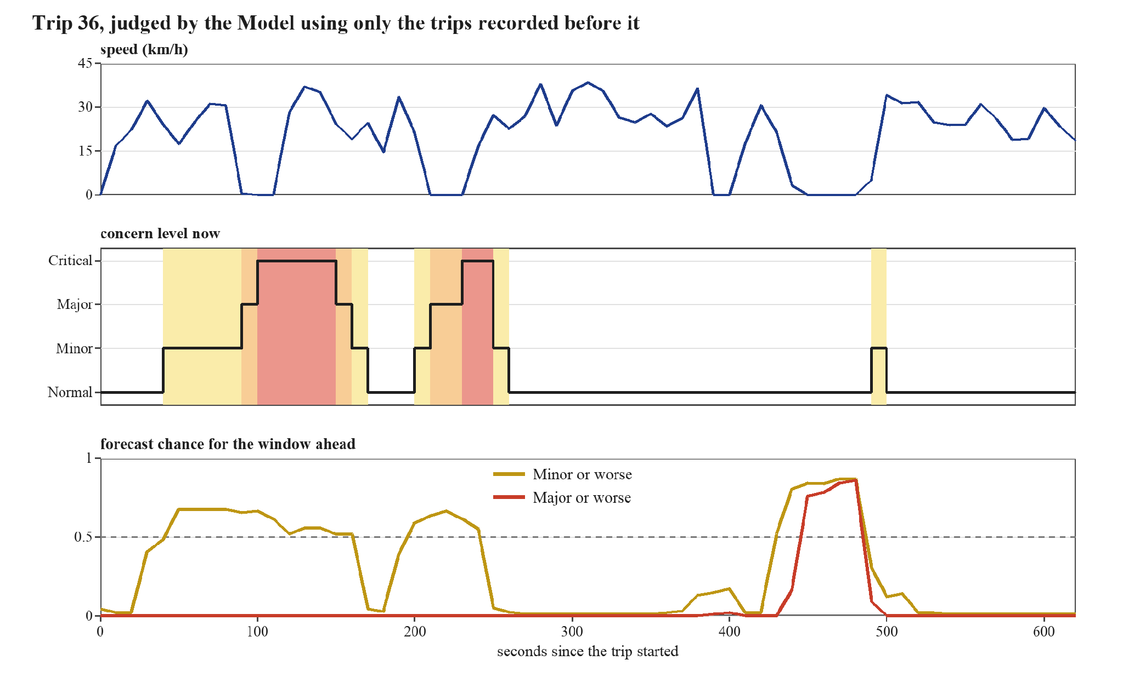
Figure 12. Trip 36: speed, the concern level now, and the forecast chances for the window ahead.
4.4 Evaluation Results (Objective 3)
The trips were judged in date order, each one using only the trips recorded before it. The first five trips were only used as history, so 55 trips and 2,727 moments were judged. Unless a section says otherwise, the Model kept all earlier trips, and the forecast window was one minute.
4.4.1 The Forecast Compared with the Baseline
The baseline assumes that the current concern level continues. Table 4.5 compares it with the forecast. An alert from the forecast means a chance of at least 0.5. An alert from the baseline means that the current level is at or above the level in question.
Table 4.5. The forecast compared with the baseline
Measure | Forecast | Baseline
Average precision, Minor or worse (higher is better) | 0.50 | 0.34
Average precision, Major or worse (higher is better) | 0.30 | 0.20
Minor or worse: share of moments the alert caught | 46% | 30%
Minor or worse: share of alerts that were right | 58% | 73%
Major or worse: share of moments the alert caught | 19% | 21%
Major or worse: share of alerts that were right | 41% | 62%
Average gap to the true level (lower is better) | 0.36 | 0.28
False alarm episodes per trip | 0.58 | 0.58
False alarm episodes per hour of travel | 4.2 | 4.2

The forecast ranks the unusual moments better than the baseline, for both Minor and Major. For Minor or worse it also catches more moments (46% against 30%), with less accuracy in its alerts. For Major or worse it does not do better than the baseline. It catches about the same share of moments, and fewer of its alerts are right. The average gap to the true level is also larger for the forecast. The two kinds of false alarm are equal at about 0.58 episodes per trip. The trips last about 8 minutes, so this is about 4 false alarms for every hour of travel.
The stated chances can be trusted fairly well. The calibration error was 0.05 for Minor or worse and 0.03 for Major or worse, which means the chances are off by only a few points on average. The confidence sets are meant to hold the true level 90% of the time. They held it 86% of the time, a little under the target, and each set had 1.2 levels on average.
4.4.2 Warning Ahead of the Current Level
A forecast is useful only if it warns earlier than simply waiting for the current level to rise. Table 4.6 compares the two in the trips where an alert for Major or worse occurred.
Table 4.6. Alerts from the forecast and from the current level (Major or worse)
Result | Trips
Both alerted | 18
Only the forecast alerted | 11
Only the current level reached Major or worse | 11
Where both alerted: the forecast alerted first | 78% of the 18 trips
Where both alerted: the middle lead of the forecast | 40 seconds

In the 18 trips where both alerted, the forecast came first in 14 of them, with a middle lead of 40 seconds. This is the best result for the forecast. The other rows show its weak side. In 11 trips only the current level reached Major, so the forecast missed them. In 11 trips only the forecast alerted, so those alerts were not followed by a Major level. Over all the judged moments, the forecast alerted in only 15% of the 85 moments where the current level was already Major or worse.
4.4.3 How the Model Behaves as the History Grows
At the start, the Model has few earlier trips to learn from. Table 4.7 groups the judged trips by the number of earlier trips in the history. Figure 13 shows the same results as bars.
Table 4.7. Results by the number of earlier trips in the history
Earlier trips | Trips judged | Average precision, forecast | Average precision, baseline | Calibration error | Confidence set held the true level | False alarms per trip
5–9 | 5 | 0.53 | 0.32 | 0.08 | 79% | 0.60
10–19 | 10 | 0.39 | 0.26 | 0.08 | 82% | 1.00
20–29 | 10 | 0.37 | 0.08 | 0.04 | 87% | 0.50
30–39 | 10 | 0.30 | 0.20 | 0.06 | 87% | 0.90
40+ | 20 | 0.16 | 0.20 | 0.02 | 89% | 0.25

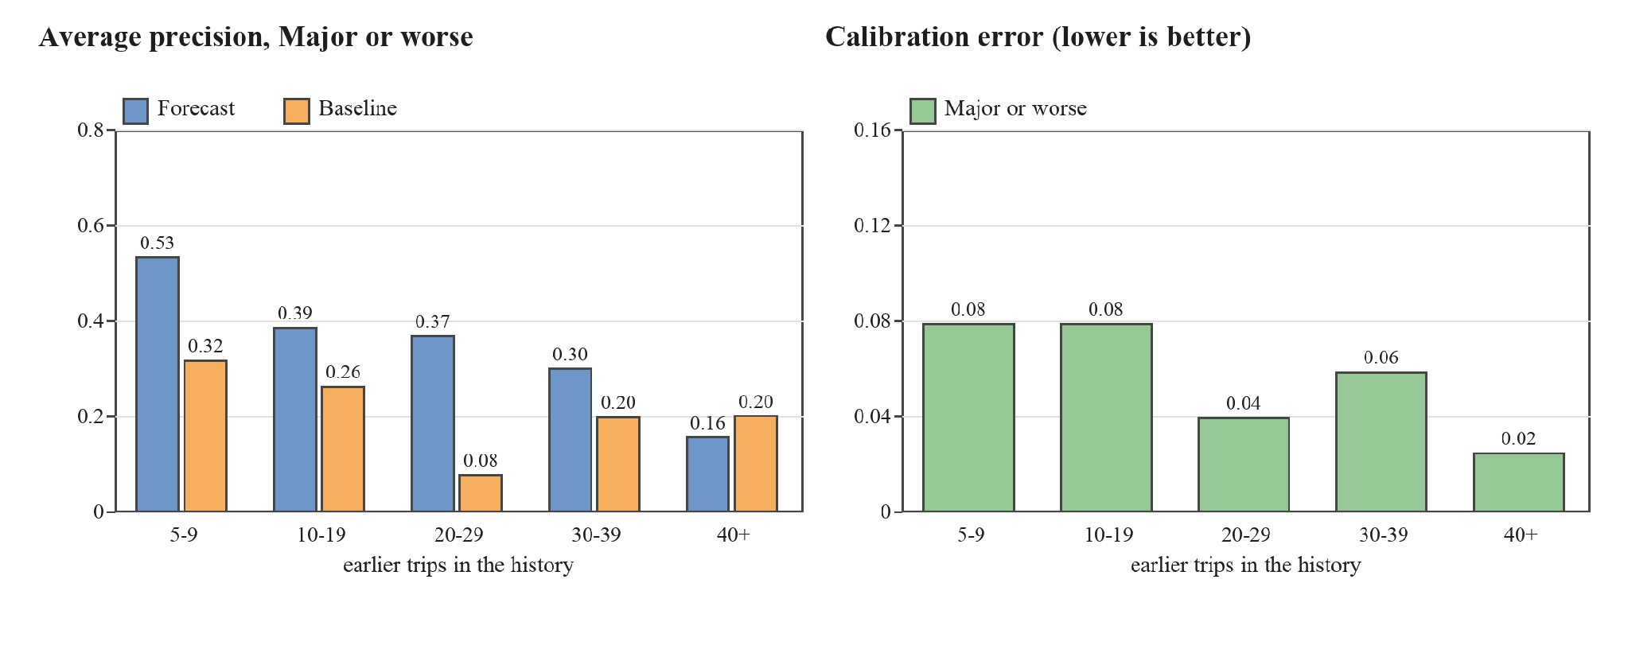
Figure 13. Average precision and calibration error by the number of earlier trips in the history (Major or worse).
The stated chances became more trustworthy as the history grew. The calibration error fell from 0.08 with 5 to 9 earlier trips to 0.02 with 40 or more, and the confidence sets came close to the 90% target in the last group (89%). The forecast ranked better than the baseline in the first four groups. In the last group, with 40 or more earlier trips, the baseline was ahead (0.20 against 0.16). The groups are small, from 5 to 20 trips, so these differences are rough and should not be over-read.
4.4.4 How Long the History Is Kept
The Model can keep all earlier trips or only the recent ones. Table 4.8 compares keeping all of them with keeping only the last 14 days or the last 7 days.
Table 4.8. Results for different history lengths
History kept | Earlier trips used (average) | Average precision, Minor or worse | Average precision, Major or worse | Calibration error, Major or worse | False alarms per trip | False alarms per hour
All earlier trips | 32.0 | 0.50 | 0.30 | 0.03 | 0.58 | 4.2
Last 14 days | 13.8 | 0.50 | 0.33 | 0.04 | 0.51 | 3.7
Last 7 days | 7.2 | 0.60 | 0.37 | 0.04 | 0.40 | 2.9

The results are mixed, and a shorter history is not clearly worse. The false alarms fell as the history got shorter (0.58, 0.51 and 0.40 per trip), and the ranking of Major or worse stayed the same or improved (0.30, 0.33 and 0.37). The trips in this dataset do not change over time, so this dataset cannot show whether old trips become misleading. The choice has to be made with more trips.
4.4.5 Starting Values That Were Tested
Some settings have no direct source, so they were treated as experiments. Table 4.9 shows what happened when each was changed. The “gain” is the forecast’s average precision for Major or worse minus the baseline’s. A larger gain means that the forecast beats the baseline by more. The last column is the share of moments whose label is Minor or worse.
Table 4.9. Results when the starting values are changed
Setting | Average precision, forecast | Average precision, baseline | Gain | Calibration error | False alarms per hour | Middle lead (seconds) | Labels Minor or worse
Forecast window 30 seconds | 0.32 | 0.24 | 0.08 | 0.02 | 4.2 | 20 | 11%
Forecast window 60 seconds (starting value) | 0.30 | 0.20 | 0.10 | 0.03 | 4.2 | 40 | 17%
Forecast window 120 seconds | 0.29 | 0.22 | 0.07 | 0.06 | 3.6 | 70 | 27%
Road stretch 50 m | 0.36 | 0.24 | 0.12 | 0.03 | 4.2 | 40 | 18%
Road stretch 100 m (starting value) | 0.30 | 0.20 | 0.10 | 0.03 | 4.2 | 40 | 17%
Road stretch 200 m | 0.30 | 0.21 | 0.09 | 0.03 | 3.8 | 45 | 18%
Strength 4 trips | 0.33 | 0.21 | 0.12 | 0.04 | 4.4 | 40 | 18%
Strength 8 trips (starting value) | 0.30 | 0.20 | 0.10 | 0.03 | 4.2 | 40 | 17%
Strength 16 trips | 0.35 | 0.22 | 0.13 | 0.03 | 4.5 | 40 | 17%
Four parts of the day (starting value) | 0.30 | 0.20 | 0.10 | 0.03 | 4.2 | 40 | 17%
Day and night only | 0.35 | 0.22 | 0.13 | 0.03 | 4.1 | 40 | 17%
No split by time of day | 0.35 | 0.22 | 0.13 | 0.03 | 4.1 | 40 | 17%
Earlier trips held out: 10% | 0.33 | 0.20 | 0.13 | 0.03 | 4.0 | 40 | 17%
Earlier trips held out: 20% (starting value) | 0.30 | 0.20 | 0.10 | 0.03 | 4.2 | 40 | 17%
Earlier trips held out: 30% | 0.31 | 0.20 | 0.11 | 0.04 | 4.8 | 40 | 17%
Route distance: the larger of the line and earlier trips | 0.30 | 0.20 | 0.10 | 0.04 | 4.4 | 40 | 27%
Route distance: earlier trips after 3 trips | 0.29 | 0.20 | 0.09 | 0.04 | 4.4 | 40 | 16%
Route distance: earlier trips after 5 trips (starting value) | 0.30 | 0.20 | 0.10 | 0.03 | 4.2 | 40 | 17%
Route distance: earlier trips after 10 trips | 0.30 | 0.20 | 0.10 | 0.04 | 4.2 | 40 | 19%

A longer forecast window gives more warning. The middle lead was 20, 40 and 70 seconds for windows of 30, 60 and 120 seconds. The gain stayed between 0.07 and 0.10, but the calibration error was larger for the longest window (0.02, 0.03 and 0.06). The one-minute window is a middle choice between warning time and the trust that can be placed in the chances. The road stretch and the strength changed the results only a little, so the starting values for those two were kept.
The split by time of day did not help. With four parts of the day the gain was 0.10, and with no split it was 0.13. The trips fall in only two parts, morning and afternoon, so the split cut the history of each part in half. The day-and-night version is the same as no split here, because no trip was recorded at night. This dataset therefore cannot show whether time of day matters, and the split is kept as an option until there are trips at other times, especially at night.
The rule for the route distance made a clear difference to the labels. With the earlier rule, which took the larger of the distance from the route line and from earlier trips, 27% of the moments had a label of Minor or worse. With the starting rule it was 17%, because the commuter’s usual detours no longer counted. The results for Major or worse hardly changed (gain 0.10 and 0.10), and the false alarms stayed close (0.60 and 0.58 per trip). The reason is that Major and Critical never came from route distance in this dataset (Table 4.4).
The share of earlier trips held out for calibration also made a small difference. Holding out 10% instead of 20% raised the average precision for Major or worse from 0.30 to 0.33 and lowered the false alarms from 4.2 to 4.0 per hour. Holding out 30% gave 0.31. The Model has little data, so giving more of it to training helps a little.
The alert limit is a choice too. Table 4.10 shows what happens when the limit on the forecast chance of Major or worse is lowered from 0.5. A lower limit catches more of the Major or worse moments, but it raises the false alarms. At a limit of 0.3, the alerts caught 40% of the moments and 42% of the alerts were right, but there were about 7 false alarm episodes an hour instead of 4. No limit fixes the problem. A limit is a trade between missing real concerns and alerting too often.
Table 4.10. The alert limit for Major or worse
Alert limit (chance of Major or worse) | Share of Major or worse moments caught | Share of alerts that were right | False alarm episodes per hour
0.5 (starting value) | 19% | 41% | 4.2
0.4 | 31% | 43% | 6.2
0.3 | 40% | 42% | 6.7
0.2 | 50% | 40% | 8.6
0.1 | 60% | 32% | 9.2

4.4.6 A Fixed Distance Rule for Comparison
A fixed rule is a simple alternative. It raises an alert whenever the vehicle is more than 150 m from the route line, which is the first level of the fixed bands used in SayfTrip (Edwards & Hosein, 2025). Table 4.11 compares it with the forecast of Major or worse over the 55 judged trips. A long stop is a finished stop of 40 seconds or more, the length that Sabir et al. (2025) call brief. A rule counts as flagging a stop or a detour if it alerts from one minute before it starts to its end.
Table 4.11. A fixed distance rule and the forecast of Major or worse
Measure | Fixed 150 m rule | Forecast of Major or worse
Alert episodes per trip | 0.69 | 0.58
Alert episodes per hour of travel | 5.0 | 4.2
Trips with at least one alert | 32 of 55 | 29 of 55
Long stops flagged (56 stops) | 6 (11%) | 28 (50%)
Episodes beyond 150 m flagged (39 episodes) | 39 (100%) | 6 (15%)

The number of alerts is about the same, but the alerts are for different things. The fixed rule alerts on every detour, including the routine ones, and it flagged only 6 of the 56 long stops, and only by chance when a stop fell inside a detour. The Model flagged 28 of the long stops and 6 of the 39 detours. Its alerts for detours are fewer because most detours are familiar. There are no trip notes yet, so this does not show which alerts were right. It shows that the Model watches for stops as well as for detours, and that it does not alert on every usual detour.
4.4.7 A Simpler Model for Comparison
XGBoost may be more than this amount of data needs. As a check, the forecast was also made with a plain logistic regression, which is a simple method that uses a few of the same inputs and the same labels. Table 4.12 compares the two on the same trips.
Table 4.12. The Model (XGBoost) and a plain logistic regression
Measure | XGBoost (the Model) | Logistic regression
Average precision, Minor or worse | 0.50 | 0.49
Average precision, Major or worse | 0.30 | 0.34
Minor or worse: share of moments the alert caught | 46% | 25%
Major or worse: share of moments the alert caught | 19% | 13%
Major or worse: share of alerts that were right | 41% | 56%
Alerts when the current level was already Major or worse | 15% | 25%
Calibration error, Major or worse | 0.03 | 0.03
False alarm episodes per hour | 4.2 | 3.2
Middle lead over the current level (seconds) | 40 | 20

For Major or worse, the simple model ranked the moments better (0.34 against 0.30), had more of its alerts right, and had fewer false alarms. XGBoost was better for Minor or worse, where it caught 46% of the moments against 25%, and it warned earlier (a middle lead of 40 seconds against 20). With only 60 trips, XGBoost has no clear advantage for the rare Major or worse moments. Its advantage is in the more common Minor moments and in earlier warning. These results come from the same trips that were used to compare the settings, so they should be confirmed on new trips.
4.4.8 Results by Direction and Running Time
Table 4.13 shows the results for each direction. They are alike in the number of false alarms. The forecast beat the baseline in both directions.
Table 4.13. Results by direction (Major or worse)
Direction | Trips judged | Average precision, forecast | Average precision, baseline | False alarms per trip | False alarms per hour
A to B | 27 | 0.25 | 0.17 | 0.59 | 4.5
B to A | 28 | 0.37 | 0.23 | 0.57 | 4.0

The Model is quick. Fitting it on the earlier trips took about 0.25 seconds (at most 0.48), and scoring a whole trip took about 0.02 seconds (at most 0.04) on the researcher’s computer. This is small enough to refit the Model after every trip.
4.4.9 Noted Unusual Events
This check could not be made yet, because no trip notes have been collected. The count of noted events flagged by the Model, and the false alarms on trips with no noted event, are left for the next results. The tool that reads the notes is ready. As a check, one stop of about 140 seconds was added to a copy of a trip with a note. The Model flagged it, and the forecast alerted 80 seconds before the noted time. This was only a check of the tool and is not a result.
4.5 Discussion
The first question asked how the trips can be recorded, cleaned, and turned into measures. This worked. The 60 trips had no data errors, and the measures of speed, stopping, and distance from the route could be worked out for every moment. The data showed three things that matter for the Model. The vehicle stopped for about a quarter of the records, it left the route line for a short while in more than half of the trips, and it took the same few other paths again and again. A fixed rule would treat many ordinary trips as unusual.
The second question asked how an Isolation Forest and XGBoost can be used together. The whole pipeline ran from the records to a forecast for every moment. The concern levels were sensible: most moments were Normal, and the higher levels came with unexpected stops and unfamiliar detours. The route distance learned the commuter’s usual detours quickly: after 5 earlier trips, 83% of the moments away from the route line were familiar. The forecast of Minor or worse worked well and sometimes warned before the current level rose. The forecast of Major or worse was weak. Its chance often stayed near zero when the current level was already Major or Critical, and it alerted in only 15% of those moments. Major and Critical moments are rare in these data (about 3% of the moments, and 9% of the labels). For a typical trip, XGBoost had only about 70 Major or worse moments to learn from. Changing its settings did not help, and a plain logistic regression ranked Major or worse better (Table 4.12). The weakness therefore comes from the small amount of data and not from a fault in the method.
The third question asked about accuracy, trust, and false alarms. The forecast beat the simple baseline on average precision, but by a modest margin, and it was not better for Major or worse at the 0.5 limit. The stated chances were close to how often they came true, and they improved as the history grew. The confidence sets held the true level 86% of the time, a little under the 90% target. The false alarms are the main problem. About 0.58 alert episodes per trip, or about 4 an hour, would be too many for real use, because people stop answering alerts that are often wrong (Cvach, 2012; Edwards & Hosein, 2025). The comparison with the fixed rule shows that the Model alerts on different things, not on fewer, and the number of alerts has to come down.
These results do not yet show that the Model is useful in the real world. They show that the method runs quickly, that the forecast can give some warning (a middle lead of 40 seconds where both alerted), that its chances can be trusted fairly well, and that it learns a commuter’s usual detours. They also show what must improve: the forecast of Major or worse, and the number of false alarms. Two results were unexpected. The split by time of day did not help, and with 40 or more earlier trips the baseline caught up with the forecast. Both may be caused by the small amount of data, and they should be checked again with more trips.
The trips also had no real incidents, and no notes exist yet. The Model flags what is unusual compared with the commuter’s earlier trips, and unusual does not mean unsafe. A long stop or a detour can have an ordinary reason. The notes will show how often the Model’s alerts match what the commuter felt was unusual, and that is the check that matters most.
4.6 Limitations and Next Steps
The results come from one commuter on one route, and from 60 trips with no night trips. The groups used for the history curve are small. Many settings were compared on the same trips, so a value that looks best here may be fitted to these trips by chance (Cawley & Talbot, 2010). Any value that is changed should be confirmed on new trips. The check against noted events is still missing.
The next steps are as follows. Collect trip notes with every trip, and add trips from more commuters, routes, vehicles, and times of day. Record at night, so that the split by time of day can be tested. Check again whether the forecast of Major or worse can be improved, and whether the false alarms can be reduced to a level a commuter would accept. Then repeat the tests in this chapter on the larger data.

References
Agapito, T. I. S., Sevillano, G. M. M., Alfonso, E. A. M., Lopez, L. C. R., Sevilla, A. B. G., & Ramos, J. C. A. (2025). Pathfinders: A public commuters' and parents' safety and assistance application. UE Research Journal, 27, 94–121.
Angelopoulos, A. N., & Bates, S. (2021). A gentle introduction to conformal prediction and distribution-free uncertainty quantification. arXiv. https://arxiv.org/abs/2107.07511
Bagheri, M., Mladenović, M. N., Kosonen, I., Nurminen, J. K., Roncoli, C., & Ylä-Jääski, A. (2020). A computational framework for revealing competitive travel times with low-carbon modes based on smartphone data collection. Journal of Advanced Transportation, 2020, Article 4693750. https://doi.org/10.1155/2020/4693750
Bakker, S., Ma, Y., & Mohammadi Ziabari, S. S. (2025). Exploring a hybrid deep learning approach for anomaly detection in mental healthcare provider billing: Addressing label scarcity through semi-supervised anomaly detection. arXiv. https://arxiv.org/abs/2507.01924
Baluan, A. R. E. L., Aguilar, A., Briones, N. C., Agustin, J., Bartolome, M. A. F., Ganitano, M. C. A., Ruiz, J. B., & Valencia, C. A. (2026). Pesopasada: A study on the impact of fuel pricing on jeepney and tricycle drivers in Sarrat, Ilocos Norte [Conference paper]. DLSU Senior High School Research Congress. https://animorepository.dlsu.edu.ph/conf_shsrescon/2026/BoA_SPL/9
Cawley, G. C., & Talbot, N. L. C. (2010). On over-fitting in model selection and subsequent selection bias in performance evaluation. Journal of Machine Learning Research, 11, 2079–2107. https://jmlr.org/papers/v11/cawley10a.html
Chen, C., Zhang, D., Castro, P. S., Li, N., Sun, L., Li, S., & Wang, Z. (2013). iBOAT: Isolation-based online anomalous trajectory detection. IEEE Transactions on Intelligent Transportation Systems, 14(2), 806–818.
Chen, T., & Guestrin, C. (2016). XGBoost: A scalable tree boosting system. In Proceedings of the 22nd ACM SIGKDD International Conference on Knowledge Discovery and Data Mining (pp. 785–794). https://doi.org/10.1145/2939672.2939785
Chen, X., Cui, T., Fu, J., Peng, J., & Shan, J. (2016). Trend-residual dual modeling for detection of outliers in low-cost GPS trajectories. Sensors, 16(12), Article 2036. https://doi.org/10.3390/s16122036
Corpuz, R. R. N., Cabrera, C. P., Tuazon, A. R., & Pangilinan, A. J. A. (2023). Public sexual harassment in public transportation in Pampanga. EPRA International Journal of Multidisciplinary Research, 9(11), 320–328. https://doi.org/10.36713/epra14837
Cvach, M. (2012). Monitor alarm fatigue: An integrative review. Biomedical Instrumentation & Technology, 46(4), 268–277.
Data Privacy Act of 2012, Republic Act No. 10173 (2012). https://lawphil.net/statutes/repacts/ra2012/ra_10173_2012.html
Deng, J., Pang, J., Xu, J., & Yu, H. (2024). Unsupervised abnormal stop detection for long distance coaches with low-frequency GPS. arXiv. https://arxiv.org/abs/2411.04422
Djon, D., Jhawar, J., Drumm, K., & Tran, V. (2023). A comparative analysis of multiple methods for predicting a specific type of crime in the city of Chicago. arXiv. https://arxiv.org/abs/2304.13464
Edwards, K., & Hosein, P. (2025). A self-contained spatio-temporal anomaly detection application for travel safety. In 2025 IEEE International Conference on Technology Management, Operations and Decisions (ICTMOD) (pp. 1–6). IEEE. https://doi.org/10.1109/ICTMOD66732.2025.11371875
Etikan, I., Musa, S. A., & Alkassim, R. S. (2016). Comparison of convenience sampling and purposive sampling. American Journal of Theoretical and Applied Statistics, 5(1), 1–4. https://doi.org/10.11648/j.ajtas.20160501.11
Frank, E., & Hall, M. (2001). A simple approach to ordinal classification. In Machine learning: ECML 2001 (pp. 145–156). Springer. https://doi.org/10.1007/3-540-44795-4_13
Gama, J., Sebastião, R., & Rodrigues, P. P. (2013). On evaluating stream learning algorithms. Machine Learning, 90(3), 317–346. https://doi.org/10.1007/s10994-012-5320-9
Gama, J., Žliobaitė, I., Bifet, A., Pechenizkiy, M., & Bouchachia, A. (2014). A survey on concept drift adaptation. ACM Computing Surveys, 46(4), Article 44. https://doi.org/10.1145/2523813
Gibbs, I., & Candès, E. (2021). Adaptive conformal inference under distribution shift. In Advances in Neural Information Processing Systems 34. https://arxiv.org/abs/2106.00170
GPS.gov. (n.d.). GPS accuracy. U.S. Government. https://www.gps.gov/systems/gps/performance/accuracy/
Guo, C., Pleiss, G., Sun, Y., & Weinberger, K. Q. (2017). On calibration of modern neural networks. In Proceedings of the 34th International Conference on Machine Learning. https://arxiv.org/abs/1706.04599
Hariri, S., Carrasco Kind, M., & Brunner, R. J. (2021). Extended isolation forest. IEEE Transactions on Knowledge and Data Engineering. https://arxiv.org/abs/1811.02141
Hyndman, R. J., & Athanasopoulos, G. (2021). Forecasting: Principles and practice (3rd ed.). OTexts. https://otexts.com/fpp3/
Kansal, S. (2020, January 9). RideCheck: Connecting you with help when you need it. Uber Newsroom. https://www.uber.com/en-IN/newsroom/ridecheck-india
Land Transportation and Traffic Code, Republic Act No. 4136 (1964). https://lawphil.net/statutes/repacts/ra1964/ra_4136_1964.html
Leys, C., Ley, C., Klein, O., Bernard, P., & Licata, L. (2013). Detecting outliers: Do not use standard deviation around the mean, use absolute deviation around the median. Journal of Experimental Social Psychology, 49(4), 764–766. https://doi.org/10.1016/j.jesp.2013.03.013
Li, P., Abdel-Aty, M., & Yuan, J. (2021). Using bus critical driving events as surrogate safety measures for pedestrian and bicycle crashes based on GPS trajectory data. Accident Analysis & Prevention, 150, Article 105924. https://doi.org/10.1016/j.aap.2020.105924
Liu, F. T., Ting, K. M., & Zhou, Z.-H. (2008). Isolation forest. In 2008 Eighth IEEE International Conference on Data Mining (pp. 413–422). IEEE. https://doi.org/10.1109/ICDM.2008.17
Lyft. (n.d.). How Lyft works to keep drivers safe. Lyft Driver Resources. https://www.lyft.com/driver/safety-resources
Mears, M., Brindley, P., Barrows, P., Richardson, M., & Maheswaran, R. (2021). Mapping urban greenspace use from mobile phone GPS data. PLOS ONE, 16(7), Article e0248622. https://doi.org/10.1371/journal.pone.0248622
Newson, P., & Krumm, J. (2009). Hidden Markov map matching through noise and sparseness. In Proceedings of the 17th ACM SIGSPATIAL International Conference on Advances in Geographic Information Systems. ACM. https://www.microsoft.com/research/publication/hidden-markov-map-matching-noise-sparseness/
Niculescu-Mizil, A., & Caruana, R. (2005). Predicting good probabilities with supervised learning. In Proceedings of the 22nd International Conference on Machine Learning (pp. 625–632). https://doi.org/10.1145/1102351.1102430
NIST/SEMATECH. (n.d.). Detection of outliers. In NIST/SEMATECH e-handbook of statistical methods. National Institute of Standards and Technology. https://itl.nist.gov/div898/handbook/eda/section3/eda35h.htm
Okamura, T., Kaneko, Y., Nakamura, F., & Wang, R. (2013). Passengers' attitudes to the service items of jeepneys in Metro Manila by different lifestyles. Journal of the Eastern Asia Society for Transportation Studies, 10, 1384–1395. https://doi.org/10.11175/easts.10.1384
Pedregosa, F., Varoquaux, G., Gramfort, A., Michel, V., Thirion, B., Grisel, O., Blondel, M., Prettenhofer, P., Weiss, R., Dubourg, V., Vanderplas, J., Passos, A., Cournapeau, D., Brucher, M., Perrot, M., & Duchesnay, É. (2011). Scikit-learn: Machine learning in Python. Journal of Machine Learning Research, 12, 2825–2830. https://jmlr.org/papers/v12/pedregosa11a.html
Reiss, T., Kour, G., Zwerdling, N., Anaby-Tavor, A., & Hoshen, Y. (2024). From zero to hero: Cold-start anomaly detection. arXiv. https://arxiv.org/abs/2405.20341
Roberts, D. R., Bahn, V., Ciuti, S., Boyce, M. S., Elith, J., Guillera-Arroita, G., Hauenstein, S., Lahoz-Monfort, J. J., Schröder, B., Thuiller, W., Warton, D. I., Wintle, B. A., Hartig, F., & Dormann, C. F. (2017). Cross-validation strategies for data with temporal, spatial, hierarchical, or phylogenetic structure. Ecography, 40(8), 913–929. https://doi.org/10.1111/ecog.02881
Sabir, M. A., Pang, J., Wu, J., & Ashraf, F. (2025). Few shot semi-supervised learning for abnormal stop detection from sparse GPS trajectories. arXiv. https://arxiv.org/abs/2510.12686
Sasikumar, S. (2026, June 4). Grab may call you during a ride. When and why it happens. Grab Stories. https://www.grab.com/inside-grab/stories/grab-safety-call-product/
Silvey, S., & Liu, J. (2024). Sample size requirements for popular classification algorithms in tabular clinical data: Empirical study. Journal of Medical Internet Research, 26, Article e60231. https://doi.org/10.2196/60231
Sørbø, S., & Ruocco, M. (2024). Navigating the metric maze: A taxonomy of evaluation metrics for anomaly detection in time series. Data Mining and Knowledge Discovery, 38, 1027–1068. https://doi.org/10.1007/s10618-023-00988-8
UN Women. (2021). Statistical evidence of women's use and experience of public transport in Kampala. https://data.unwomen.org/publications/statistical-evidence-womens-use-and-experience-public-transport-kampala
Verma, R., Mittal, S., Lei, Z., Chen, X., & Ukkusuri, S. V. (2024). Comparison of home detection algorithms using smartphone GPS data. EPJ Data Science, 13, Article 6. https://doi.org/10.1140/epjds/s13688-023-00447-w
Viechtbauer, W., Smits, L., Kotz, D., Budé, L., Spigt, M., Serroyen, J., & Crutzen, R. (2015). A simple formula for the calculation of sample size in pilot studies. Journal of Clinical Epidemiology, 68(11), 1375–1379. https://doi.org/10.1016/j.jclinepi.2015.04.014
Yuan, Y., Huang, Y., Wu, Y., & Wang, J. (2024). AnomalyAID: Reliable interpretation for semi-supervised network anomaly detection. arXiv. https://arxiv.org/abs/2411.11293
Zhang, D., Li, N., Zhou, Z.-H., Chen, C., Sun, L., & Li, S. (2011). iBAT: Detecting anomalous taxi trajectories from GPS traces. In Proceedings of the 13th International Conference on Ubiquitous Computing (UbiComp '11) (pp. 99–108). ACM.
Zheng, Y. (2015). Trajectory data mining: An overview. ACM Transactions on Intelligent Systems and Technology, 6(3).

